Chemistry 350
Organic Chemistry I

Laboratory Manual



Course team

Author: Dietmar Kennepohl

Laboratory Development
Specialist: Carmen Allen

Laboratory Instructors: Jason Norman, Cherry Ibarra Romero, Myron Wilde

Course Professor: Dietmar Kennepohl

Every effort has been taken to ensure that these materials comply with the requirements of copyright clearances and appropriate credits. Athabasca University will attempt to incorporate in future printings any corrections which are communicated to it.

The inclusion of any material in this publication is strictly in accord with the consents obtained and Athabasca University does not authorize or license any further reproduction or use without the consent of the copyright holder.

© Athabasca University 2025
Printed in Canada

CHEM 350 Lab Manual Contents

General Introduction 5
Organization 6
Evaluation 6
Safety 8
Online Laboratory Resources 15
Experiment 1 Melting-point Determinations 17
Experiment 2: Recrystallization 26
Experiment 3: Distillation 33
Experiment 4: Refractive Index 39
Experiment 5: Extraction, separation and the use of drying agents 45
Experiment 6: Infrared Spectroscopy Tutorial 65
Experiment 7: Extraction of Usnic Acid from Lichen 72
Experiment 8: Preparation of Cyclohexene from Cyclohexanol 82
Experiment 9: The Nitration of Acetanilide 91
Lab Data Sheet 100

Acknowledgements

The experiments described in this laboratory manual are mainly variations of similar experiments that may be found described in the laboratory manuals of other universities or in commercially produced lab texts. Each experiment has been modified and rewritten, keeping the needs of Athabasca University students in mind.

We are indebted to past authors of this lab manual including Lawton Shaw, David Law, Rob Carmichael, Lois Browne, and Arthur Last. We also wish to thank Gilda Sanders and Erna Dominey for valuable editing comments over the years, as well as Aimee Caouette, Blaise MacMullin, and Ian Grivois, for the artwork and photography. The authors also thank Lois Browne, Nyron Jaleel, Klaus Thomson, Ross Witherell, Jason Norman, Cherry Ibarra Romero, Melissa Gajewski for their continuous feedback and suggestions for improvement to the manual over the years.

Athabasca University also wishes to thank Drs. K. Tanabe and T. Tamura and for all the infrared spectra used in this manual, obtained from the SDBS web site: https://sdbs.db.aist.go.jp/sdbs/cgi-bin/direct_frame_top.cgi

General Introduction

Welcome to the laboratory component of Athabasca University's Organic Chemistry I (CHEM 350). This course, together with Organic Chemistry II (CHEM 360), constitutes the equivalent of a second-year university introductory organic chemistry course. Although the laboratory component of this course will involve a lot of work, we hope that you will find the experience both intellectually stimulating and enjoyable. One of the benefits of having a compulsory laboratory component in a course such as ours is that it gives students an opportunity to meet lab instructors and other Athabasca University students in person.

In the CHEM350 lab, you will receive approximately 24 hours of in-lab instruction, spread over three days. You should also expect to put in an additional 24 hours in preparation and writing lab reports. Students attending the in-person supervised lab session can expect the following:

a. Hours of work. At each day-long laboratory session, you will be working for approximately eight hours. Your instructor will ensure that you take a proper lunch break, but we also recommend that you take morning and an afternoon refreshment break. Regular breaks make it easier for you to concentrate while you are working and will decrease the chances of an accident. We also recommend that you take a brief walk outside during a break to get some fresh air.

- Feedback. The laboratory sessions are done in a concentrated fashion, with all experiments in the course being done in a few days during one visit. However, as you write up your laboratory reports, it is strongly suggested that you submit only a few reports at a time (especially the first experiments). This will allow your academic expert to provide you with constructive feedback that you can use in writing subsequent reports.

c. Preparation. Athabasca students must prepare several experiments for each day of laboratory work. For example, before attending the first laboratory session, you must read through Experiments 1-4, making sure that you understand exactly what you will be doing, noting possible problems, and so on. The lab manual will list preparations needed at the beginning of each experiment. This might include additional activities such as answering pre-lab questions or watching a video or preparing a work/procedural flowchart.

Organization

The laboratory component of Chemistry 350 comprises approximately 24 hours of supervised laboratory work. The laboratory sessions may differ from other laboratory classes that you have attended, in that not all the students will be working on the same experiment at any given time and the experiments are not necessarily exactly 3 hours in length. Your lab instructors will help guide the work schedule of the lab class, considering availability of instruments and other factors. However, you must be prepared to do more than one experiment at a time.

Materials to be Provided by the Student

When attending a CHEM 350 laboratory session, each student must provide the following items:

- an electronic calculator.
- a lab notebook, to record observations and results.
- a pen, a pencil and a ruler.
- a black ‘Sharpie’ marking pen for making labels.

Evaluation

All students must work individually, except where otherwise indicated in the lab manual or by the lab instructor; pairing up and the pooling of data, solutions, etc., is not permitted.

Your lab reports must be legible and preferably typed. Although neatly handwritten and scanned PDF documents are permitted for the Short Forms, you will need to type the Formal Reports.

Note that the penalties for plagiarizing laboratory reports are identical to those incurred for other types of plagiarism. See Athabasca University Student Academic Misconduct Policy: https://www.athabascau.ca/university-secretariat/_documents/policy/student-academic-misconduct-policy.pdf

You must attain an average of 60% for laboratory work to pass the course. The laboratory component is 20% of your final composite grade in the whole course.

Most labs (Experiments 1, 2, 5-8) only need a short report form filled in. However, there are two (2) longer ‘journal-style’ formal reports (one for Experiment 3/4 combined and one for Experiment 9) required. Please see the Writing Laboratory Reports section for details.


Marking of Laboratory Reports

Your laboratory reports should be emailed as separate PDF attachments (Experiment 3 and 4 are combined) to your academic expert within 1 month of your last supervised laboratory session. (NB: Currently there is no option to use the assignment drop box within the LMS.)

[Hint: Do not send all reports in at the same time. Initially send only 1-2 reports to first obtain feedback for later reports.]

For the laboratory component of the course there is a practical grade (15%) assigned based on your in-lab performance (e.g., organization, safety, tidy bench, etc.). Then each experiment has a weighted score (see experiment listing in Table of Contents).

Laboratory Examination

Currently, there is no written lab exam for the CHEM 350 laboratory component.

Safety

General

Some people will approach the laboratory component of their Athabasca University chemistry course with a certain amount of trepidation. In a sense, this is a good thing—no one can afford to adopt a complacent attitude towards laboratory safety. However, you should realize that you could well face a greater chance of being killed or injured as you drive to the laboratory session than you will while you are working in the laboratory. Most of the hazards that you are likely to face while performing the experiments in this laboratory are relatively minor and easily avoided. They include:

minor cuts—most cuts can be avoided if a student never uses broken or cracked glassware and is particularly careful when carrying out potentially dangerous operations, such as inserting glass tubing into a rubber stopper.

burns—burns usually occur when a student forgets that something which has just been heated on a hot-plate or in a heating mantle may be very hot.

chemical spills—spills can usually be avoided if students pay particular attention to the technique used when pouring chemicals from a container, and injury caused by spills can be minimized if students wear the appropriate protective clothing: safety glasses, gloves, and lab coat or apron.

Another possible danger is the presence of hazardous gases or vapours in the air. In this course, we have kept the use (or production) of such materials to a minimum. Where eliminating such materials is not practical, you will be advised to work in a fume hood, which will protect both you and your co-workers from exposure to undesirable concentrations of toxic or otherwise unpleasant vapours.

When designing the laboratory component of this course, we found it necessary to strike a balance between minimizing possible hazards and exposing you to a full range of techniques. By its very nature, chemistry often necessitates the handling of dangerous substances; if chemistry students are never exposed to such situations, we would never have any fully trained chemists. Having said this, perhaps we should reassure you that, provided you follow the safety rules that follow, we do not anticipate that any problems will arise.

Safety Rules

- Safety glasses must always be worn in the laboratory. Wearers of prescription glasses may wear their own eyeglasses but should be aware of the possibility that chemicals or flying glass could enter the eye through the gap between the temple and the frames of the glasses. Thus, in potentially hazardous situations, wearers of spectacles are advised to wear safety goggles or a safety mask over their prescription glasses. Contact lenses must not be worn in the laboratory.
Note 1: Safety glasses will be provided by Athabasca University and must always be worn—even when you are not actively using chemicals and glassware. Remember that injury could result through carelessness on the part of one of your fellow students.
Note 2: Contact lenses are not permitted for two reasons.
  - If a chemical is splashed into the eye of a person wearing contact lenses, neither the normal tearing mechanism nor external irrigation (with water) is effective in removing chemicals from under the contact. The contact must first be removed before tearing and irrigation is effective; however, the contact may be difficult to remove because of the tight squeezing shut of the eye that occurs in response to the chemical in the eye. Since time is of the essence with a chemical burn, a delay caused by the necessity of removing a contact lens could have serious consequences.
  - Soft contact lenses present an additional hazard. Any chemical (including vapours) that contacts such a lens can diffuse into the interior of the lens, which then acts as a reservoir that can create additional exposure, even if the lens is removed and rinsed.
Note 3: The correct emergency treatment for chemicals that enter the eye is to wash the injured eye thoroughly with plain water for 15 minutes. Medical attention should be sought for all eye injuries. An eye-wash fountain should be available in the laboratory; make sure that you are aware of its location.
- A lab coat must be always worn. A lab coat will protect you and your clothes if you inadvertently spill a chemical.

- Wear closed toe shoes. Remember that you will be “on your feet” for up to eight and one-half hours on any given lab day.
- Tie back long hair. Long hair can be a fire hazard. Also, when you bend over to inspect the contents of a beaker containing a chemical, long hair can easily fall into that chemical. Not only could this damage your hair, but it could also ruin your experiment!
- Never run in the laboratory and never be tempted to become involved in practical jokes or other horseplay.
- On no account attempt an unauthorized experiment.
- Never work in the laboratory when the supervisor is not in attendance. Our regulations require that at least one qualified supervisor be present in the laboratory whenever a student is working there.
- Eating, drinking and smoking are not permitted in the laboratory. Food and drink may become contaminated by toxic substances. Smoking is a fire hazard. When you leave the laboratory, wash your hands, particularly before eating.
- In the event of fire:
- do not panic; many small fires can be extinguished without the use of a fire extinguisher, simply by cutting off the air supply. For example, when a flammable liquid ‘catches’ fire in a beaker, the fire can quickly be put out by placing an asbestos pad or watch-glass over the beaker.
- if the use of a fire extinguisher is necessary, leave it to the supervisor and concentrate on getting yourself to the nearest exit.
- if your instructor is incapacitated (e.g., through injury), be prepared to extinguish a fire, especially if human life is in danger. To do so, you must know the location of the nearest fire extinguisher and how to use it. Most of the extinguishers that you will encounter are of the ABC type, which means they are effective on fires involving trash, wood or paper (Class A), liquids and grease (Class B), and electrical equipment (Class C). These extinguishers are not effective on Class D fires. (i.e. those involving active metals such as sodium and potassium). Fires involving the latter substances are unlikely to occur during a Chemistry 350 lab, but you should be aware of the special problems that these materials can cause. When using a fire extinguisher, aim at the base of the fire and use a sweeping motion. Note that you should never attempt to extinguish a laboratory fire using water. (A possible exception might be to extinguish a burning paper towel by placing it in a sink and turning on the tap.)
- if your clothing catches fire, wrap yourself in a fire blanket (or a coat if no fire blanket is available) and roll on the ground.
10. Report all accidents. All accidents, however minor, must be reported to your supervisor and the details entered online in the Student Incident Report Form (QR code below). If you are involved in an accident, do not resume work until you have received the appropriate first aid or medical attention. Never work with open cuts on your hands; cover all small cuts and scratches with ‘band-aids’.
11. Always dispose of chemical wastes in the correct manner. In general, you would never dispose of chemicals, particularly organic solvents, by pouring them down the drain. Throughout the Chemistry 350 laboratory manual you will find that you are told repeatedly to “pour excess reagents into the waste container provided”. Ensure that waste chemicals are placed in the correct container—putting the wrong material into a container is potentially dangerous. Never attempt to return “used” chemicals to their original containers. Note that certain substances, such as dilute acids or solutions of “harmless” compounds (e.g., sodium chloride), etc., may be washed down the drain with copious amounts of water. When in doubt, check with your instructor. Be particularly careful to place any chlorinated hydrocarbons in the waste container designated for such substances.
12. Never pour concentrated inorganic acid (e.g., H₂SO₄) or base into a bottle marked ‘Organic Waste only’. Violent exothermic reactions can occur between potential reagents, causing a splatter of toxic and corrosive material.
- Never over fill a waste bottle. Keep an eye on the volume level in the waste bottle and let the instructor know when it is ¾ full.

Some General Advice About Laboratory Work

- People with clean and tidy benches are less likely to be involved in accidents. Communal areas, such as balance rooms and fume hoods, should also be kept tidy. Clean up all spills. Any glassware containing chemicals that is left in a communal area should be clearly labelled with the owner's name and details of the contents (e.g., L. Worker, concentrated nitric acid).
2. Do not rummage through a cupboard or communal glassware/supply drawer or box without care and attention. Sharp object may be present. Discard sharp objects (needles, razor blades, broken glass in the appropriate sharps discard receptacle.
3. Wear your lab coat at all times when working in the lab and wear protective latex gloves whenever handling corrosives and solvent. Do not store sharp objects (e.g., Pasteur pipettes) in your coat pocket.
4. When assembling apparatus or glassware, always check with the instructor before proceeding with the experiment.
5. Handle all organic solvents (e.g., acetone, dichloromethane) with care. Most are flammable, and many have a long-term, cumulative effect on the body.
6. If a fire starts, or the fire alarm sounds, unplug any electrical apparatus and vacate the laboratory in an orderly manner.
7. When diluting a concentrated acid, always add the acid to the water. Do so slowly, with stirring.
- If you get acid on your clothing, neutralize it with dilute ammonia solution (1 mol⋅L⁻¹) and wash well with water.
- If you get alkali on your clothing, wash it off with large quantities of water.
- If you get any corrosive chemical on your skin, wash it off immediately with water and consult your instructor. Pay special attention to the safety notes given in bold type in the “Procedure” sections of the lab manual. These notes will inform you of any special precautions that you might need to take and will also inform you if the “wash well with water” maxim does not apply.
- If you spill a large quantity of acid on the bench or floor, use crude sodium bicarbonate (available from the instructor) to neutralize the acid and then wash well with water.
- Always check for any possible hazards associated with using a given chemical. Read the label on the container and check for hazard symbols. When in doubt, consult your instructor.
- As mentioned in the safety rules, all accidents that result in injury must be reported to your supervisor and the details entered online in the Student Incident Report Form.

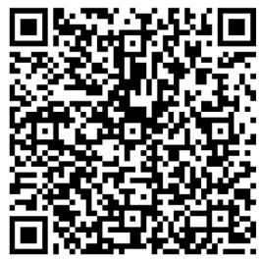

WHMIS

** You are required to complete the WHMIS (Workplace Hazardous Materials Information System) course on health and safety in the workplace before beginning the laboratory component of this course. **

Under “WHMIS Training” of the “Laboratories” section of the online course you can access the training and/or provide a certificate of successful completion. There are three main features of WHMIS:

1. Chemical manufacturers are now obliged to label each container of hazardous material, giving details on the product's hazards and what action to take in an emergency.

2. The manufacturer must provide the consumer with a Safety Data Sheet (SDS) for each hazardous product. These sheets give complete details on the possible health effects that exposure to the product can produce, preventive measures that should be taken, etc.

3. Employers must provide an appropriate education program for all workers whose work may bring them into contact with hazardous products.

The WHMIS regulations do not affect you as a student, although if you are involved in a chemistry-related job you should be familiar with them. Most of the chemicals that you will handle in this course are no longer in their original containers. Under the WHMIS regulations, such chemicals do not require detailed labels. However, you should read all labels carefully and pay special attention to the hazard warnings that appear throughout the laboratory manual. The hazard symbols that you may observe on certain chemical containers are reproduced on the following page. A file containing up to date SDSs for all the chemicals used in Chemistry 350 is maintained at each of the locations where laboratory sessions for these courses are held. Additional information on WHMIS may be obtained from Alberta Community and Occupational Health, Occupational Health and Safety Division.

Hazard Symbols

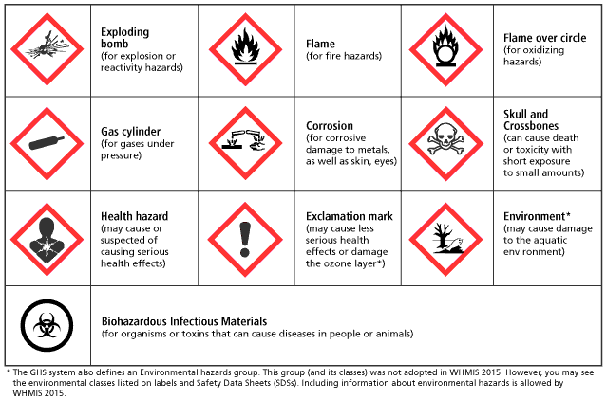

From the Canadian Centre for Occupational Health and Safety
(https://www.ccohs.ca/images/oshanswers/pictogram_names.gif)

Online Laboratory Resources

Organic Chemistry Lab Resources
Find background information, unknowns, etc

Lab Registration/Booking

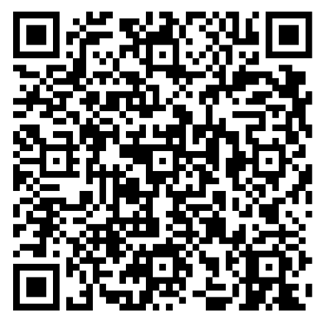

Lab Schedule
upcoming chemistry lab sessions


Lab Exemptions
to recognize equivalent lab work done elsewhere



Student Incident Report Form
all accidents that result in injury must be reported to your supervisor and the details entered here
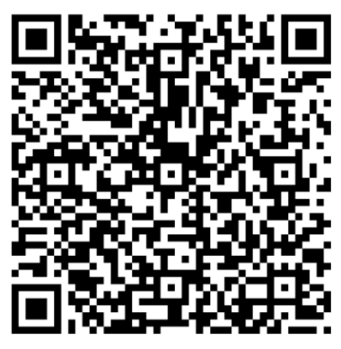

Athabasca University Student Academic Misconduct Policy


Student Support Centre
course-related academic and logistical inquiries

fst_success@athabascau.ca

Experiment 1
Melting-point Determinations

Preparation

Before you come to the laboratory you should have read the background information and completed the pre-lab questions.

Watch video on melting point determination accessed at:

(Although our procedure is somewhat different, this University of Alberta experiment will give you an idea of what to expect.)

Introduction

This experiment contains two parts. In the first part, you will determine the melting point of an unknown, then check with your instructor on the accuracy of your reading. In the process you will learn how to fill a melting point tube, how much sample to place into the tube, how to operate the melting point apparatus. Finally, you will observe the four stages of a melting point.

In the second part, you will determine the identity of an unknown compound using the mixed melting point procedure. You will determine an initial melting point of just your unknown and use this information to select the two best candidates from the group of possible unknowns (Figure 1.2). The quickest way to determine the identity of your unknown is to prepare three melting point tubes, the first containing your unknown, the second your unknown mixed with candidate 1, and the third, your unknown mixed with candidate 2. Read all three tubes simultaneously in the melting point apparatus. Your unknown will melt at the same time as the mixed sample containing the correct candidate.

Unknown Solid
Unknown
Solid + Cand.1
Unknown
Solid + Cand.2
Melts first (broad range)
Unknown
Solid + Cand.2
heat
Unknown Solid
Unknown
Solid + Cand.1
more heat
Unknown
Solid + Cand.1
Unknown Solid
Both melt simultaneously (sharp range)
Time
Candidate 2
is not your unknown
Candidate 1
is your unknown

Unknown Samples

Figure 1.2: Melting Points (°C) of Unknowns Used

Using the Electrothermal Melting-point Apparatus – DigiMelt (MPA 160)

a) b)
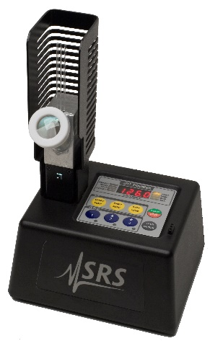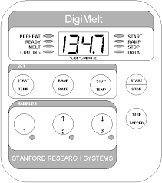

Figure 1.3: a) Melting point apparatus b) Top view of the melting point apparatus

- Push Start Temp (see Figure 1.3b) and use the ↑/2 and ↓/3 buttons to set the starting temperature (generally 5 degrees below the expected melting point).

- Push Ramp Rate and use the ↑/2 and ↓/3 buttons to set the ramp rate (2 deg/min is suggested).

- Push Stop Temp and use the ↑/2 and ↓/3 buttons to set the stop temperature (at least 5 degrees above the expected melting point).

- Push Stop Temp again to return to the current temperature display.

- Load capillaries with sample. Insert capillaries into the chassis holes near the Tube Tapper button. Press the Tube Tapper button to pack your samples.

- Push Start/Stop to preheat the block to the starting temperature. The Preheat LED will light.

- When the Ready LED becomes lit, the oven is holding at the start temperature. Insert your samples into the DigiMelt oven.

- Push Start/Stop to begin ramping the temperature at the ramp rate. The Melt LED will light.

- Observe your samples during the ramp.

- Push the 1, ↑/2 and ↓/3 buttons to record data (up to 4 temperatures per sample) during the melt. (To end the experiment before the stop temperature is reached, push the Start/Stop button.)

- When the Cooling LED is lit, the experiment is over. If you recorded data, the Data LED is also lit.

- To read back the data, push the 1, ↑/2 and ↓/3 buttons (make sure the Cooling LED is lit)

When observing the sample through the illuminated magnifying lens, you may be able to observe four stages of melting:

- first signs of change (for example, shrivelling).

- first signs of liquid formation (1st drop). Record the lower limit at this point

- formation of a meniscus.

- formation of a completely clear melted liquid. Record the upper limit.

1-2mm
packed
solid
Time
Solid
Melted
Meniscus
1st Drop
Shrivelling

Not all samples will behave in this ideal manner. The range that you should record is that for steps 2 and 4 (i.e., from the first sign of liquid formation to the formation of a completely clear liquid).

If the melting point of the sample is unknown, you will need to employ a slightly different procedure from that described above. Your first step will be to determine the approximate melting point by carrying out a “preliminary run,” employing a rapid rate of heating throughout. Once the approximate melting point has been determined, you may proceed as described above.

Procedure

To Prepare a Melting Point Sample

- Place about 0.1 g (a small amount) of the compound onto a porous plate, watch glass or in a mortar. Crush the solid to a fine powder by gently rubbing it with the flat end of a spatula or pestle.

- Transfer a small quantity of the fine powder to the capillary tube by pushing it in the open end.

- Pack the sample by using the Tube Tapper on the DigiMelt instrument or a ‘drop tube’. The packed sample should be 1-2 mm in height.

Use just enough of the material so you can see it melt.

sample
1-2 mm
Closed end
of tube

Part A: Single Melting-point Determination

Determine the melting point of the unknown sample provided (limited to compounds shown in Figure 1.2). The approximate melting point of the sample is provided in the table below, so that you can decide on the most appropriate setting for the melting point apparatus. Your first step will be to determine the approximate melting point by carrying out a “preliminary run,” employing a rapid rate of heating throughout. Once the approximate melting point has been determined, you may proceed measure once more with a slow Ramp Rate (not more than 2° C/min).

Part A: List of Compound Codes Used as Simple Melting Point Unknowns

Unknown Code | Melting Point is within the range of:
1-A-1 | 50-100° C
1-A-2 | 100-150° C
1-A-3 | 150-250° C
1-A-4 | 60-120° C
1-A-5 | 90-140° C
1-A-6 | 180-270° C

Part B: Mixed Melting Point

You will be assigned an unknown sample (limited to compounds shown in Figure 1.2). Determine the melting point of your assigned compound using the “melting-point method”. Identify the top two (2) possible candidates based on the melting point you obtained.

Acquire a small amount of pure sample of each of these possible candidates.

Crush a sample of your compound with each of these compounds that you believe it could be (50:50 mixture), load both into melting point tubes, and then determine the melting point of each of these mixtures. From your results, deduce the identity of the unknown compound.

Write-up

Fill in the following form below and answer the post-lab questions. Use the Word version of the report form so you can add additional space for your answers. When complete, save as a PDF and email as an attachment to your Academic Expert for grading.

[Hint: Do not send all reports in at the same time. Initially send only 1-2 reports to first obtain feedback for later reports.]

CHEM 350 Experiment 1 Report Form

Melting-point Determinations

Date:___________

Student Name:___________________ ID Number:___________

Part A

Melting point of sample # ____________ = ______________

Suggest identity of unknown compound _____________

Part B

Possible identity of unknown compound # _____________ :

1. _____________ ; m.p. (Reference )

2. _____________ ; m.p. (Reference )

Melting point of unknown compound # ____________ = _____________

Melting point obtained when unknown compound # ____________ is mixed with

1. ______________ = _______________

2. ______________ = _______________

Conclusion: The above results indicate that unknown compound # __________ is probably _________.

Questions

- In the introduction to this experiment, you were warned that heating the sample too quickly in the region of the melting point will result in the experimentally determined melting point being higher than the true value. Explain why this is so.

- What is a “eutectic mixture”? How would you decide whether a given sample was a pure compound or an eutectic mixture of two compounds?

- You are working in the lab, and you find an unlabelled vial with a white crystalline solid inside. To determine the identity of the compound, what would you do?

I certify that this submitted laboratory report represents entirely my own efforts. I have read and understand the Athabasca University policies regarding, and sanctions for, plagiarism.

Signature: __________________________ Date: __________________________________

Experiment 2:
Recrystallization

In this experiment you will be given an impure sample of acetanilide (contaminated with sucrose (soluble impurity), calcium carbonate (insoluble impurity), and possibly silica. You will recrystallize acetanilide, using water as the solvent.

Preparation

Before you come to the laboratory you should have read the background information and completed the pre-lab questions.

Watch videos on recrystallization, gravity filtration, and vacuum filtration accessed at:

(Although our procedure is somewhat different, this University of Alberta experiment will give you an idea of what to expect.)

About Handling Hot Glassware and Hotplates

- At all times use hand protection (finger cots, ‘hot-hands’, or insulated gloves) when holding heated glassware.

- Do not place a dry empty flask on the hot plate. It will crack.

- The surface of the hot plate is like a clothes iron. You cannot see if it is hot!! Hot plates are the most frequent source of burns to the skin in the laboratory.

- Never fill and heat a flask more than 2/3 full (even with boiling stones). The solvent will boil over.

Erlenmeyer Flasks vs. Beakers

Beakers are not used for a recrystallization. Erlenmeyer flasks are used instead. Why?

- Erlenmeyer flasks have a narrow neck that allows some refluxing of the solvent and thus slows the rate of solvent evaporation.

- The narrow neck of an Erlenmeyer flask also allows you to swirl the liquid, thereby aiding in dissolving the solid.

- A flask can be stoppered to prevent evaporation during the cool down. You cannot easily stopper a beaker.

- It is only slightly more difficult to remove crystals from an Erlenmeyer flask than a beaker.

Procedure — Single Solvent Recrystallization

1. In this experiment, Step 1 of recrystallization, ‘selecting the solvent’, has already been done for you. Water dissolves acetanilide when hot, and acetanilide is highly insoluble in cold water.

2. Dissolving the acetanilide.

- Take a small sample of the impure acetanilide in a test tube and label it as crude acetanilide. Set it aside for a melting point analysis. Measure out approximately 5 g of the impure acetanilide into a 250 mL Erlenmeyer flask. Add 25 mL of distilled water to the flask and heat it on a hot plate until the water begins to boil.
- While waiting for the water to boil, prepare approximately 150 mL of distilled water in another 250-mL Erlenmeyer flask. Add one or two boiling stones to the flask and heat it on a hot plate.
- In a third 250-mL Erlenmeyer flask, place 25 mL of deionized water. Set up a plastic funnel with a folded filter paper in the funnel's neck.
- Once the solution from step a reaches a boil, observe if all the solid has dissolved completely. If not, add about 5 mL more water from the flask prepared in step b. Continue adding hot water from the second flask to the acetanilide until all the solid has dissolved. Keep in mind that the sample contains impurities, so not all the solid will dissolve immediately. Wait until the solution is boiling to ensure an accurate assessment of dissolution. If necessary, continue adding water in the same manner until mostly complete dissolution is achieved.
- Remove the boiling solution from the hot plate and let it cool briefly to prevent 'bumping.' Add a pinch of activated charcoal, then carefully bring the solution back to a boil in preparation for hot gravity filtration.

3. Hot gravity filtration.

- Place the flask with the funnel you prepared in step 2.c on the hot plate, along with the flask containing the acetanilide solution, and wait for both solutions to boil.
- Once both solutions are boiling and the filter paper in the funnel is wet, filter the acetanilide solution. Keep the unfiltered acetanilide solution close to boiling at all times.
- When the filtration is complete, pour 5-10 mL of boiling water through the filter paper, particularly if it appears that some of the acetanilide has crystallized onto the paper. If major crystallization has occurred, consult your instructor.

Cautionary Note: It is very tempting to turn the hot-plate control to its highest setting during the above steps, but you should try to resist this temptation as it is likely to result in the solution “boiling over”. In this experiment we have used water as a solvent, and so there is no risk of fire. In later experiments the solvents that you use to recrystallize your products are likely to be flammable. When a flammable solvent contacts an overheated hot plate, fire can result. Always use an appropriate setting on your hot plate, never leave a flask or beaker heating on a hot plate unattended, and do not forget to use a new boiling stone each time you heat or reheat a liquid or solution.

- Crystal Formation

Turn off the hot plate and remove the flask, placing it on your bench. Allow the solution to cool while you proceed with another experiment. If crystals have started to form in the flask during filtration (step 3d above), re-dissolve them by warming the flask. In extreme cases, such as if the entire contents of the flask solidify, consult your instructor.

5. Vacuum or Suction filtration.

a. After the filtrate has been cooling for 25-30 minutes, a good crop of crystals should have formed and the Erlenmeyer flask containing these crystals should be placed in an ice-bath for a further 10-15 minutes. During this time, the apparatus for performing a vacuum filtration should be set up.
b. Filter off the acetanilide crystals (from the surrounding liquid; called the 'mother liquor'), washing the crystals with a small quantity of cold distilled water. Allow the crystals to dry for at least an hour.

Note: Do not discard your filtrate until after your instructor has determined whether you need to obtain a “second crop” of crystals.

Final Analysis: Melting-point determination.

- Determine the mass of pure, dry acetanilide obtained and calculate your percentage yield.

- If you have already completed Experiment 1, determine the melting point of your starting material and product. If you have not yet completed Experiment 1, please do so before you attempt to determine the melting point of your recrystallized acetanilide.

- After obtaining your sample yield and determining its melting point, dispose of it as instructed by your lab instructor.

Optional: The “second crop.”

If your yield is particularly low, for example, if you used an excessive amount of solvent, your instructor may advise you to obtain a “second crop” of crystals. Transfer the filtrate obtained from the vacuum filtration to a 250-mL Erlenmeyer flask, add a boiling stone and a pinch of activated charcoal, and then boil this solution until its volume has been reduced to about 25% of its original volume. Carry out a hot gravity filtration as before, allow the filtrate to cool, and separate the crystals from the mother liquor by vacuum filtration. After the crystals are dry, determine the yield and melting point of this second crop. Note that second-crop crystals are often not as pure as those obtained in the first crop.

Write-up

Fill in the following form below and answer the post-lab questions. Use the Word version of the report form so you can add additional space for your answers. When complete save as a PDF and email as an attachment to your Academic Expert for grading.

[Hint: Do not send all reports in at the same time. Initially send only 1-2 reports to first obtain feedback for later reports.]

CHEM 350 Experiment 2 Report Form

Recrystallization

Date:___________

Student Name:___________________ ID Number:___________

Procedure:
(Ref: )
Changes/Modification:

Results

Table 1. Observations
Procedural Step | Comment or Observation
Recrystallization solvent used.

Volume of recrystallization solvent used.

Hot filtration (solids present)

Appearance of solution after addition of charcoal

Time allowed for crystals to form.

Second crop . . .

Table 2. Product Recrystallization Results
 | Mass of Impure Acetanilide (g) | Mass of Pure Acetanilide Recovered (g) | Appearance of Crystals | % Recovery Yield | Melting Point  (°C)
Impure acetanilide
'Pure' acetanilide
2nd crop 'Pure' acetanilide

Show % recovery yield calculation for your first crop.

Questions

1. The table below shows the solubility of a certain organic compound in water at five different temperatures.

Temperature (º C) Solubility of compound (in 100 mL water)
0 1.5 g
20 3.0 g
40 6.5 g
60 11.0 g
80 17.0 g

a. Plot a graph of the solubility of the compound versus temperature. Draw a smooth curve through the data points.
b. If a student attempts to recrystallize a 0.5 g sample of this compound by heating it to 80º C with 5.0 mL of water, would all of the sample dissolve? Briefly justify your answer.
c. Assuming that the answer to part b is “Yes”, at what temperature will the crystals begin to appear when the student’s solution begins to cool?
d. If the student cooled the solution to 0º C and filtered off the crystals, what is the maximum possible percentage recovery? What mass of the sample will remain in the filtrate?

- Explain why you should slowly cool the hot filtered saturated solution obtained in the recrystallization procedure?

- During the last step of the recrystallization procedure, you collect the crystals by vacuum filtration. Why do you use ice cold recrystallization solvent to help transfer all the crystals to the Büchner funnel and wash the crystals?

- Briefly explain the circumstances under which a mixed solvent recrystallization method would be used to recrystallize a given compound.

I certify that this submitted laboratory report represents entirely my own efforts. I have read and understand the Athabasca University policies regarding, and sanctions for, plagiarism.

Signature: __________________________ Date: __________________________________

Experiment 3:
Distillation

Preparation

Before you come to the laboratory you should have read the background information and completed the pre-lab questions.

Watch videos on simple distillation and fractional distillation accessed at:

(Although our procedure is somewhat different, this University of Alberta experiment will give you an idea of what to expect.)

Chemicals, Equipment, Utilities Required:

All equipment used must be clean and free of any organic contamination.

Chemicals | Equipment | Utilities
cyclohexanol (impure),  toluene  vacuum (glass joint) grease  distilled water  ice  wash acetone | -heating mantle, lab jack, retort stands, utility clamps  -distillation apparatus (distillation flask, three-way connector, thermometer adapter, condenser, vacuum adapter, receiving flask, fractionation column, boiling stones)  -hazardous waste disposal containers (in fume hood) | -115V electrical,  -cold water supply

Distillation Glassware

- Remember to inspect all glassware for star-cracks (especially the distillation round bottom flask).

- When connecting the water tubing to your condenser, remember that water enters from the bottom of the condenser and exits from the top. By forcing the water uphill, it will completely fill the condenser. The flow of water should be than a trickle, but should not be so strong that the hose flops around from the high water pressure.

Boiling Stones

- Boiling stones must be used to promote smooth boiling and prevent 'bumping' of the liquid. Boiling stones contain many air filled pores. Air is slowly forced from the stone's pores as the vapour of the liquid being distilled penetrates the pores. The steady escape of air from the boiling stone results in a smooth boil.

- Never add a boiling stone to a solution that is already hot! A violent degassing of the liquid might result, which will cause the hot liquid to splatter out of the vessel. Also, when ‘re-boiling’ a liquid, use a fresh boiling stone.

Heating Mantles

- Do not use a heating mantle with a damaged electrical cord.

If you have any doubts about how to use the heating mantle provided, please consult the instructor before you begin the experiment. When using a heating mantle keep the following points in mind:

- a heating mantle is a good general purpose heating device suitable for flammable solvents with boiling points from ~40 to 160° C.

- heating mantles are available in various sizes. Always choose the correct size of heating mantle for the round-bottom flask you are using. (Note: If the correct size is not available, use glass wool to pack around the sides and bottom of the round-bottom flask to ensure a snug fit).

3. heating mantles tend to warm up slowly. Be patient, and do not use too high a setting.

4. A heating mantle is generally at a higher temperature than the round-bottom flask that it is heating. Also, heating mantles cool down very slowly. If the reaction (or distillation) being carried out gets out of control, it serves no purpose to simply unplug the heating mantle. In such situations, the heating mantle must be removed, thus, the apparatus should always be assembled with the heating mantle supported above the bench by an iron ring or, better still, on a laboratory jack (a lab jack).

5. Heating mantles are designed for heating round-bottom flasks. Never try to heat an Erlenmeyer flask or a beaker with a heating mantle.

6. Never add reagents to a flask while it is sitting in a heating mantle.

Procedure

In the first part of this experiment, you will purify a sample of cyclohexanol (bp 161º C) by simple distillation. The reason that we have chosen to use cyclohexanol is because you will use this compound in a later experiment, and the purified sample that you obtain today can be saved for use in the later experiment. The second part of today's experiment involves the separation of a mixture of cyclohexane and toluene by fractional distillation. In Experiment 4 you will determine how successful this separation has been by measuring the refractive index of a number of fractions of the distillate.

Part A: Simple Distillation

Place 35 mL of impure cyclohexane in a clean 100-mL round-bottom flask and add one or two boiling stones to the liquid. Set up the apparatus for simple distillation as shown in Figure 3.2 with a 25-mL round-bottom flask as the receiver and supporting the heating mantle (i.e., the ‘heat source’) using a lab jack. Pay particular attention to the positioning of the thermometer (range: −10º to 260º C / blue thermometer): the top of the bulb should be level with the bottom of the side arm (see Figure 3.4, below).
Figure 3.4. Thermometer placement during a simple distillation
Begin to heat the cyclohexanol by turning on the heating mantle to a setting of 6 or 6.5. After 10-15 minutes, the liquid will start boiling and the thermometer reading will begin to rise. Note the temperature when the first drop falls into the receiving flask. Wait until the thermometer stabilizes around 140°C, record this temperature, and then replace the receiver with a clean 25-mL round-bottom flask.*. The cyclohexanol should distill at a rate of about 10-20 drops per minute (monitor the chilled water supply to the condenser to prevent cyclohexanol from solidifying. Ensure the condenser is filled with water, but keep the tap closed). Record the temperature range over which this fraction distills. This is the boiling range (i.e., the boiling point) of cyclohexanol and it should be in the order of 140-160º C. Collect about 14-15 mL of cyclohexanol in this way; that is continue until only a few millilitres of liquid remain in the distillation flask, or until the temperature recorded on the thermometer begins to increase. Remember: Never distill to dryness. Use a graduated cylinder to measure the volume of distillate collected, transfer the distilled cyclohexanol to a suitable labelled container, and keep it in a safe spot to be further analysed. Your sample will be used in Experiments 4 and 8. Waste the first few millilitres of distillate that you collected, called the fore-run, and the cyclohexanol that remained in the distillation flask as instructed.

Part B: Fractional Distillation

Place 25 mL of the cyclohexane-toluene mixture in a 100-mL round-bottom flask and add one or two boiling stones to the mixture. Assemble the apparatus for fractional distillation using a fractionating column as shown in Figure 3.2. Use a heating mantle (supported by a lab jack) as the ‘heat source.’ Slowly heat the contents of the flask (a setting of 3-4 on the heating mantle is about right to begin with) and watch the vapours rise in the column. When the vapours begin to reach the bulb of the thermometer, reduce the rate of heating so that for several minutes the ring of condensing vapours is kept between the top of the column packing and the sidearm. This procedure allows the vapour composition to stabilize before any distillate is collected. Now, turn up the heat slightly so that the mixture begins to distil. Collect the first few millilitres of fore-run in a small round-bottom flask and discard this material in the container provided. Collect three fractions of distillate in three different clean, dry, round-bottom flasks. The first fraction will consist of material that distills below 85º C, the second fraction will consist of material that distills between 85º C and 100º C, and the third fraction will consist of material that distills above 100º. You may increase the distillation rate for the final fraction, as there is no further fractionation to be done at that point.

For each fraction, measure the volume using a graduated cylinder, and measure the refractive index using a refractometer (see experiment 4). These measurements can be made while the distillation is ongoing, or fractions may be stored to measure later necessary. You will need to re-use the round bottom flask used to collect fraction one for fraction three, so measure the volume promptly after switching fractions and place the flask on its side to allow the residual liquid to evaporate. Once the volume and refractive index have been measured and you have noted the appearance of the liquid, it can be disposed of as non-halogenated waste.

Safety

Cyclohexanol is flammable, irritating to the skin and eyes, and is harmful if inhaled or ingested.
Cyclohexane is flammable and may irritate the skin, eyes and respiratory tract. Avoid contact with the liquid or its vapour and keep it away from hot surfaces and open flames.
Toluene is flammable. Prolonged inhalation, ingestion or skin absorption may result in nausea, headaches, vomiting and dermatitis. Avoid contact with the liquid, do not breathe its vapours, and keep it away from hot surfaces and flames.

Additional information about the potential hazards involved in handling these chemicals may be obtained from the Material Safety Data Sheets that are available in the laboratory.

Write-up

One single formal report of Experiments 3 and 4 together will be required. Use the formal report template (Word) and follow the instruction outlined in “Writing Laboratory Reports.” When complete save as a PDF and email as an attachment to your Academic Expert for grading.

Experiment 4:
Refractive Index

Preparation

Before you come to the laboratory you should have read the background information and completed the pre-lab questions.

The Abbé Refractometer

Refractive indices are measured using a refractometer. The particular instrument that you will be using in this experiment is an Abbé-3L refractometer. A diagram of the refractometer is shown in Figure 4.2.
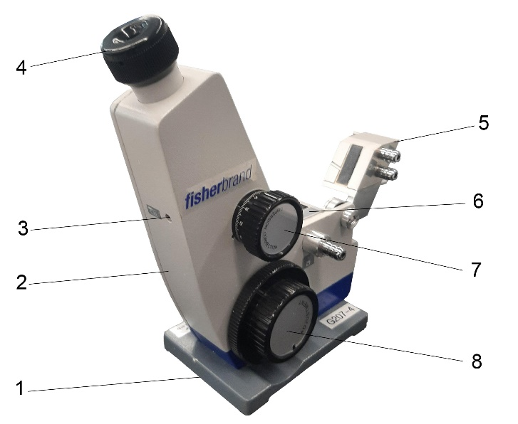

1. Baseplate 9. Condenser
2. Housing 10. Thermometer
3. Adjustment screw 11. Reflection mirror
4. Eyepiece 12. Protective plate
5. Illumination prism 13. Prism lock
6. Measuring prism
7. Scatter settings
8. Measuring range adjusting wheel

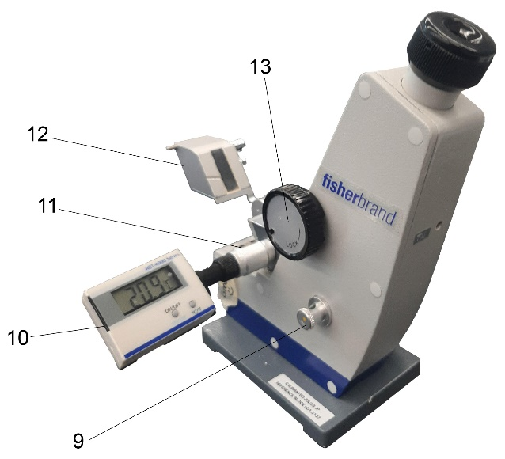

Figure 4.2. Abbé-3L refractometer

You need not be concerned with the details of how the optical system of the refractometer works. A thin film of sample is introduced between two prisms using an eyedropper, the sample is illuminated, and the experimenter looks into an eyepiece. The illuminating lamp is adjusted until the best contrast between the light and dark halves of the visual field is obtained. The hand-wheel [8] on the side of the instrument is then rotated until the dividing line between the light and dark halves of the visual field coincides with the centre of the crosshairs (see Figure 4.3). There are two scales shown. The bottom is the Brix scale (% dissolved solids) and the top is refractive index (n_{D}).

Figure 4.3. View through the eyepiece of a correctly adjusted refractometer

Chemicals, Equipment, Utilities Required

In Part A of this experiment, you will use the product obtained in Experiment 3A.

In Part B of this experiment, you will use the products obtained in Experiment 3B.

All equipment used must be clean and free of any organic contamination.

Chemicals | Equipment | Utilities
cyclohexanol (impure and pure),  toluene, cyclohexane  Exp. #B fractions 1-3  wash acetone | -Refractometer, Pasteur pipettes  -hazardous waste disposal containers (in fume hood) | -115V electrical,

Final Warning about Using the Abbé Refractometer

Please be careful. Do not scratch the surface of the glass on the refractometer.

Procedure

Part A: Refractive Index of Cyclohexanol

For this part of the experiment, use the impure and purified cyclohexanol that you obtained from the simple distillation in Experiment 3. See the instructor if your sample has not yet been returned to you.

- Make sure your hands are dry before handling the refractometer and ensure that the refractometer is plugged into a main outlet.

- Open the illumination prism [5] by turning the locking mechanism [13]. Apply one or two drops of the liquid (i.e., cyclohexanol) onto the measuring prism [6].

Caution: Do not touch the prism with your Pasteur pipette. The prism is easily scratched by any hard object, and scratching will wreck the instrument.

- Move the illumination prism [6] down again and secure using the locking [13] mechanism. A thin film of liquid will form between the surfaces of the two prisms.

- Open the protective plate [12] and close the reflection mirror [11].

- Focus the image by turning the adjusting wheel [7] right or left while looking through the eyepiece [4]. Then move through the measuring range turning the measuring range adjusting wheel [8] right or left.

- When the light/dark boundary in the upper window is congruent with the crosshairs, the value can be read off in the upper scale of the lower window (Figure 4.3). Consult your instructor if necessary.

- If the borderline between the light and dark areas of the visible field appears as a coloured band (see Figure 4.4), chromatic aberration (colour dispersion) is said to have occurred, and you must achromatize the borderline. Achromatization can be achieved by rotating the compensator dial located just below the eyepiece.

Coloured band
Bright upper half
Dark bottom half

Figure 4.4. Chromatic aberration

- Open the hinged prism and gently clean the two surfaces with a soft tissue made damp with acetone, ethanol or petroleum ether. When the solvent has evaporated from the prism surfaces, they should be locked together. Remember: do not touch the surfaces of the prisms with any hard or abrasive substance.

- Proceed to Part B, or if you have completed the experiment, turn off the instrument.

Part B: The Composition of a Toluene-Cyclohexane Mixture

- Using the instructions given in Part A as a guide, determine the refractive index of each of the following mixtures:

- the toluene-cyclohexane mixture used in Experiment 3.

- the three fractions retained from the fractional distillation carried out in Experiment 3. (Note: work quickly as sample will evaporate.)

- Look up and record the literature values for the refractive indices of toluene and cyclohexane.

Safety

Cyclohexane is flammable and may irritate the skin, eyes and respiratory tract. Avoid contact with the liquid or its vapour and keep it away from hot surfaces and open flames.

Toluene is flammable. Prolonged inhalation, ingestion or skin absorption may result in nausea, headaches, vomiting and dermatitis. Avoid contact with the liquid, do not breathe its vapours, and keep it away from hot surfaces and flames.

Additional information about the potential hazards involved in handling these chemicals may be obtained from the Material Safety Data Sheets that are available in the laboratory.

Write-up

One single formal report of Experiments 3 and 4 together will be required. Use the formal report template (Word) and follow the instruction outlined in “Writing Laboratory Reports.” When complete save as a PDF and email as an attachment to your Academic Expert for grading.

Questions

Answers are to be included with your report.

- Suggest a reason why the boiling point of cyclohexanol is so much higher than those of cyclohexane and toluene.

- Suggest a reason why the refractive index of cyclohexanol is higher than that of water.

- To reduce the percentage error in the n_{D} reading of your purified cyclohexanol (compared to the literature value), what should you do?

- Is there a way you could suggest to improve the experiment (should you do it again)?

Experiment 5:
Extraction, separation and the use of drying agents

Preparation

Before you come to the laboratory you should have read the background information and completed the pre-lab questions.

Watch video on liquid-liquid extraction accessed at:

(Although our procedure is somewhat different, this University of Alberta experiment will give you an idea of what to expect.)

Read the section on “Flowcharts” and see the example shown in Figure 5.3. Before you come to the laboratory, you should create a flow-chart for the separation of organic base (steps 6-8).

In addition
- review Unit 2 “Polar Covalent Bonds; Acids and Bases” in the wiki textbook.

Introduction

In this experiment, you will be given an unknown solid containing three organic compounds, one acidic, one basic and one neutral. You will separate the mixture using the extraction procedure, isolate the separated compounds, and then identify the individual compounds using mixed melting points. The compounds you will be working with are shown below.

Solubility Flow Diagram for Classification of Organic Compounds

Unknown compound
soluble
insoluble
water
soluble
insoluble
basic
acidic
neutral
Low C#:
alcohol
aldehyde
ketone
amide
ester
aromatic amine
phenol
Low C#:
carboxylic acid
phenol
Low C#:
aliphatic amine
aromatic amine
amine
5% NaOH
5% HCl
soluble
Litmus Paper Test
carboxylic acid
phenol
High C#:
alcohol
aldehyde
ketone
amide
ester
unsaturated cmpd
(aromatic cmpd)
aromatic
hydrocarbon or halide
soluble
insoluble
H₂SO₄
5% NaHCO₃
insoluble
soluble

Redrawn from Lehman, J.W. 1999. Operational Organic Chemistry 3rd ed., Prentice Hall, p.534.

Chemicals, Equipment, Utilities Required

All equipment used must be clean and free of any organic contamination.

Chemicals | Equipment | Utilities
unknown organic solid mixture,  dichloromethane,  5% NaOH,  1.5 M HCl,  12 M conc. HCl,  6M NaOH,  distilled water,  ice,  methanol,  ethanol,  ethyl acetate,  hexanes,  wash acetone. | -separatory funnel and stopper, ring clamp, powder funnel  -125 ml Erlenmeyer flasks (3-4)  -10 mL graduated cylinder (2), Pasteur pipettes (2), stirring rod, pH indicator paper, water-ice bath  -filter flask, Büchner funnel plus adapter, vacuum tubing, Whatman #1 filter paper circle  -flat bottomed recrystallization dish, hot plate, Erlenmeyer flasks (2), sample vials plus labels  -melting-point apparatus  -rotary evaporator apparatus  -halogenated and non-halogenated organic waste disposal containers (in fume hood) | -water aspirator,  115V electrical outlet

Handling Separatory Funnels and Dichloromethane

- Inspect your separatory funnel for ‘star-cracks’. Ensure that the stopper is the correct size for the separatory funnel. Pre-test your separatory funnel with acetone to check for leaks from the stopper or stopcock region.

- Very lightly grease the stopper and stopcock to prevent leaking, sticking or freezing of the ground glass joints. If the separatory funnel has Teflon® stoppers and stopcocks, greasing is not necessary, since Telfon® is self-lubricating.

- Also, choose the size of the separatory funnel so that the total volume of liquid in the funnel is less than 75% of the total capacity of the funnel.

- Latex gloves provide little protection against dichloromethane. Use the Viton® rubber gloves provided when handling this solvent. Use the halogenated organic waste container to dispose of unused / used dichloromethane.

The Use of the Büchi Rotavapor

The organic chemist is frequently faced with the problem of having to evaporate a relatively large volume of solvent from a solution. Although distillation is often employed to remove the solvent from such solutions, this can be a long and tedious process during which it is possible that the solvent, the product, or both may start to decompose. One method of overcoming such problems is to distill off the solvent under reduced pressure. You will recall that lowering the applied pressure will lower the boiling point of a liquid.

Rotary evaporators are commonly employed to reduce the volume of solutions by evaporating off the solvent at a reduced pressure, the model that you are most likely to use in this course is the Büchi Rotavapor-R110 (see Figure 5.1).

The solution to be evaporated is placed in flask A (note that this flask should never be more than half full) which is then attached to the vapor duct, B, using the clip provided. The joint should, of course, be greased in the normal manner. Sometimes a splash head is used between the evaporating flask and the vapor duct. The receiving flask, C, is then attached to the condenser using the clamp provided, and if it is not already in position, the introduction stopcock, D, should be inserted. Connect the cooling water (if not already connected) and carefully turn on the tap. Thick-walled rubber tubing should now be used to connect the outlet E to the aspirator. The aspirator is turned on and the evaporating flask is partially immersed in the water bath by raising the water bath to a suitable height on a lab jack (not shown in Figure 5.1). With the model R110 rotavapor it is possible to lower the evaporating flask into the water bath, eliminating the need for a lab jack. The evaporating flask is then made to rotate at a suitable speed by adjusting the control F, and the water in the water bath is heated if necessary. It is possible to refill the evaporator flask without interrupting the evaporation process, but you are unlikely to need to do this.

When the volume of the solution has been reduced to the desired amount, stop the flask from rotating, turn off the aspirator, either lower the water bath or raise the evaporating flask (depending on the model used) and remove the evaporating flask from the apparatus.

Your instructor will assist you when you first use the rotary evaporator. However, by the end of the course you should be comfortable using this useful piece of equipment.

Figure 5.1. A Büchi Rotavapor
(Model used may not be exactly as illustrated.)

Calculation of conc. HCl needed to neutralize a given amt. of base.

Given: # of mol of acid to add = # of mol of base used
NaOH conc. = 5%
Tot.Vol. NaOH used = 50 mL
conc. HCl = 12 M

1. Convert Weight Percentage (%) of Base to Molarity (M)

Need: M = mol/L and Mwt = g/mol or mol = g/Mwt.
substitute for mol
Therefore: M = g/Mwt/L

Since: 5% NaOH means 5 g/100mL NaOH (or 50 g/1000 mL)

Calculate: M= (5 g)/(40.00 g/mol)/0.1 L or ((50 g)/(40.00 g/mol)/1 L)
M= 1.25 mol/L

2. Determine the Number of moles of Base Used

Using: M= mol/L or mol = M x L

Calculate: mol = 1.25 M x 0.05 L
mol = 0.0625 mol (must use the same # of mol of acid to neutralize)

3. Determine the Number of mL of Acid Required to Neutralize the Base

Using: M= mol/L or L = mol/M

Calculate: L = 0.0625 mol/12 M
L = 0.0052 L
or Vol. = 5.2 mL of conc.HCl req. to neutralize 50 mL of 5% NaOH.

Summary Equation: mol Acid = mol Base (using M = mol/L)
or M Acid × L Acid = M Base × L Base
Thus: L Acid = (M base) × (vol Base)/(M Acid)
L Acid = ((5 g)/(40.00 g/mol)/0.1 L) × 0.05 L Base)/12 M Acid
L Acid = 0.0052 L

Procedure

Part A: Extraction of the Organic Acid and Organic Base

You will be provided with about 3 g of a mixture containing an unknown organic acid, an unknown organic base and naphthalene.

1. Determine the mass of your sample and transfer the solid to a separatory funnel that is supported by an iron ring attached to a retort stand (see Figure 5.2).

2. Add ~25 mL of dichloromethane and add 20 mL of 5% sodium hydroxide solution. Swirl the separatory to dissolve most of the solid, then stopper the funnel and invert and vent it by opening the stopcock. When no further pressure release can be heard when the stopcock is opened, shake the funnel gently for approximately 30 seconds, or until all of the solid has dissolved.

Figure 5.2. Use of a separatory funnel

3. Return the funnel to the iron ring, remove the stopper, and allow the layers to separate. Draw off the bottom layer (dichloromethane) through the stopcock into a 125-mL Erlenmeyer flask labelled “dichloromethane.” Pour the aqueous layer out through the top of the funnel into another 125-mL flask and set it to one side for the time being. Be sure to label this Erlenmeyer flask clearly. The top layer from this step contains the salt of your organic acid dissolved in aqueous base.

4. Return the dichloromethane layer to the separatory funnel and add a second 20-mL portion of 5% sodium hydroxide solution. Shake, vent and allow the layers to separate as before. Draw off the lower (dichloromethane) layer into a 125-mL Erlenmeyer flask and pour the aqueous layer out through the top of the funnel into the Erlenmeyer flask containing the aqueous layer from the first separation. Return the dichloromethane layer to the separatory funnel and add a second ~20-mL portion of 5% or 1.0 M sodium hydroxide solution. Stopper, invert, vent, shake gently and allow the layers to separate as before. Draw off the lower (dichloromethane) layer into the dichloromethane flask.

5. Return the top layer from step 3 to the separatory funnel and add 10-15 mL of dichloromethane. Stopper, invert, vent and shake gently allow the layers to separate, and drain the lower organic layer into the 125-mL Erlenmeyer that already contains the dichloromethane from before. Pour the aqueous layer through the top of the funnel into the 125-mL Erlenmeyer that has previously been used for storing this solution and place the flask in an ice bath.

Confused? Take a moment to review what you have done so far. You should now have two 125-mL Erlenmeyer flasks. One of these flasks contains approximately 40 mL of dichloromethane in which the naphthalene and organic base are still dissolved. The second flask contains an aqueous solution of the sodium salt of the organic acid, plus any excess sodium hydroxide. Let us now separate the organic base from the naphthalene.

6. Pour the dichloromethane solution of naphthalene and the organic base into the separatory funnel and add 15-20 mL of 1.0 or 1.5 mol L⁻¹ hydrochloric acid. Shake, vent and separate as described previously. Drain the lower layer into the dichloromethane flask and pour the upper layer into your third 125 mL Erlenmeyer flask. Be sure to label the new Erlenmeyer flask clearly. The top layer from this step contains the salt of your organic base dissolved in aqueous acid.

7. Return the dichloromethane solution to the separatory funnel and extract with a further 15-20 mL of 1.0 or 1.5 mol L⁻¹ hydrochloric acid.

8. Combine the two hydrochloric acid extracts and wash the combined solution with 15 mL of dichloromethane. Combine the dichloromethane washings with the dichloromethane solution that you should have saved from the acid extraction. Return the aqueous layer to the flask previously used for it and place the flask in an ice bath.

Let us review the situation again. You should now have three 125-mL Erlenmeyer flasks, each containing a solution. The first flask contains an aqueous solution of the sodium salt of the organic acid; the second flask contains an aqueous solution of the hydrochloride salt of the organic base; and the third flask contains a solution of naphthalene in dichloromethane. The next phase of the experiment is to isolate the organic acid, the organic base, and the naphthalene.

Part B: Isolation of the Organic Acid

1. Inspect the cooled Erlenmeyer flask containing the aqueous sodium hydroxide extract. If there is a significant amount of dichloromethane on the bottom, remove as much of the dichloromethane as possible using a Pasteur pipet. Place the Erlenmeyer flask that contains the sodium hydroxide extract into an ice bath and carefully add cold concentrated or 6.0 M hydrochloric acid until your organic acid precipitates (Note: You need enough acid to neutralize all the base used in the extraction along with enough excess to precipitate all of your organic acid. Ensure that you are able to calculate the volume of hydrochloric acid required before you came to the laboratory.) A precipitate of the organic acid should form. If a precipitate forms and then redissolves, you will need more acid. If there is only a small amount of precipitate, add more acid until it appears that no more precipitate is forming. If available, Use litmus paper (or universal indicator paper) to test the pH of the mixture. It should be strongly acidic (pH < 2) and to ensure that a slight excess of hydrochloric acid has been added so that all of the organic acid will be precipitated. Return the flask to the ice bath for at least 5 minutes, then filter off the precipitate by suction filtration, and wash the solid obtained several times with ~10-mL aliquots of ice-cold distilled water.

- Allow the solid to dry under vacuum for at least 10 minutes and then return it to the Erlenmeyer flask it came from. Recrystallize the crude acid from an appropriate solvent. Begin by attempting to dissolve the acid in ~10 mL of water. Add more water if the water boils but the solid does not dissolve. If you find that there is 50+ mL of boiling water in your flask and very little of the crude acid has dissolved, start adding ethanol instead of water until the acid has dissolved. When the acid has fully dissolved, allow the flask to cool and crystallize, cool further in ice, then vacuum filter and wash the solid with ice cold water. Neither charcoal nor hot filtration is not normally required for this recrystallization.

- When the recrystallized product has fully dried, determine its yield (mass) and melting point. From the given list of possible organic acids, identify the one that was most likely present in your mixture. Confirm your deduction by the mixed melting point technique if necessary.

Part C: Isolation of the Organic Base

1. Inspect the cooled Erlenmeyer flask containing the aqueous sodium hydroxide extract. If there is a significant amount of dichloromethane on the bottom, remove as much of the dichloromethane as possible using a Pasteur pipet. Place the Erlenmeyer flask that contains the hydrochloric acid extract into an ice bath and carefully add cold sodium hydroxide solution (6 mol L⁻¹) to the cooled flask containing the aqueous hydrochloric acid extract. (Note: You need enough base to neutralize all the acid used in the extraction along with enough excess to precipitate all of your organic base. Ensure that you can calculate the approximate volume of sodium hydroxide required before you come to the laboratory.) Continue the dropwise addition of the sodium hydroxide solution until the pH of the solution in the Erlenmeyer flask is about > 10. (Use universal indicator paper to verify the pH.) A precipitate of the organic base should appear. If universal indicator paper is not available, continue adding small amounts of 6.0 M NaOH until no more precipitate forms.

Note: If your organic base appears as an oil rather than as a precipitate, follow the procedure given at the end of this section.

2. Return the flask to the ice bath for at least 5 minutes, then filter off the precipitated organic base by suction filtration and wash the solid several times with 10-mL aliquots of ice-cold distilled water. Allow the solid to dry under vacuum for at least 10 minutes and then return it to the Erlenmeyer flask it came from.

If your base is a deep yellow colour, it can be recrystallized from boiling water. If your base is white you will need to do a two solvent recrystallization using water and methanol. Begin by adding a small amount (~5 mL) of methanol and heating until it starts to boil. Add room temperature deionized water from a wash bottle in a constant stream until the solution turns cloudy. Allow the solution to warm until the solid redissolves, then allow it to cool and crystallize. The total volume of solvents used should not exceed 20 mL.

3. When the recrystallized product has dried, determine its melting point. From the given list of possible organic bases, identify the one that was most likely present in your mixture. Confirm your deduction by the mixed melting point technique. Determine the yield (mass) of product obtained.

If your organic base appeared as an oil instead of a solid, transfer the contents of the Erlenmeyer flask to a separatory funnel. Wash the Erlenmeyer flask with three 15-mL aliquots of dichloromethane and transfer these washings to the separatory funnel. Shake and vent the funnel and allow the layers to separate. Run the (lower) dichloromethane layer into a clean 125-mL Erlenmeyer flask. Wash the aqueous solution remaining in the funnel with an additional 15 mL of dichloromethane and combine the washing with the dichloromethane solution in the Erlenmeyer flask. Dry the dichloromethane solution by adding anhydrous magnesium sulfate to the solution, placing a cork in the mouth of the Erlenmeyer flask, and allowing it to stand for about 10 minutes. Filter off the drying agent (gravity filtration) and evaporate off the dichloromethane using the rotary evaporator (if necessary, see your instructor for assistance). A solid organic base should be obtained. Purify the base by the method described in 3, above.

Part D: Isolation of the Neutral Hydrocarbon (optional)

1. Transfer the dichloromethane solution that contains the neutral hydrocarbon (naphthalene) from its Erlenmeyer flask to a separatory funnel. Wash the dichloromethane layer with two 20-mL aliquots of distilled water.

2. Run the dichloromethane into a 125-mL Erlenmeyer flask and dry this solution by adding anhydrous magnesium sulfate, placing a cork in the mouth of the flask, and allowing it to stand for about 10 minutes.

3. Filter off the drying agent (gravity filtration) and evaporate off the dichloromethane using the rotary evaporator (if necessary, see your instructor for assistance).

4. Naphthalene can be readily purified by the process of sublimation. Note: If your instructor has substituted some other hydrocarbon for naphthalene, please consult her or him before you proceed with this stage of the experiment.

5. Transfer the crude naphthalene into a clean, dry 100-mL beaker and stand the beaker on a hot plate. Clamp a 50-mL round-bottomed flask filled with ice-cold water in such a way that the bottom of the flask is in the mouth of the beaker. (Note: The outside of the flask must be dry.)

6. Gently warm (alternate between low and off) the beaker by turning on the hot plate to a low setting. If the naphthalene melts, you are heating too strongly. After a short while, crystals of naphthalene will appear on the bottom of the flask. When the crystals are large, scrape them off into a vial and collect a second crop. Continue with this procedure until most of the naphthalene has sublimated.

7. Determine the melting point and yield of your product.

Flow-charts

The procedure described above may seem long and complicated. The student who carries out the experiment with one finger on the instructions is quite likely to make a mistake (e.g., by skipping a line) and rarely understands the significance of each step in the procedure. It is often a good idea to prepare a flow- chart for any given experiment before you come to the laboratory. The flow- chart can be used during the experiment to guide you through all the necessary steps, in the correct order. In addition, the very act of trying to condense several pages of instructions into a one-page flow- chart can assist you in obtaining a better understanding of how each step in the procedure fits into the overall experiment. (Note: For this experiment, a series of short flow-charts might be more appropriate than one large one.) The flow-chart shown in Figure 5.3 summarizes steps 1-5 in Part A of this experiment. Before you come to the laboratory, you should create a flow-chart for the separation of organic base (steps 6-8).

Figure 5.3. Example of a flow-chart to separate organic acid

Safety

Dichloromethane (methylene chloride) is harmful if inhaled, swallowed or absorbed through the skin. Wear gloves and eye protection. Use in well-ventilated area or fume hood. Potential carcinogen.

Sodium hydroxide is corrosive. Skin contact is harmful. Can cause severe burns and is dangerous to the eyes. Wear gloves and eye protection.

Hydrochloric acid is harmful to eyes, lungs and skin. If concentrated, use only in a fume hood. Wear gloves and eye protection.

Benzoic acid, 4-methylbenzoic acid, 2-methylbenzoic acid, 4-chlorobenzoic acid and salicylic acid do not present any specific hazards, but all the usual precautions should be taken, e.g., avoid ingestion, skin contact, etc.

3-Nitroaniline is toxic. It can be absorbed through the skin, so wear gloves. Avoid breathing dust. In case of contact, wash exposed area with water for at least 15 minutes.

4-Chloroaniline does not present any specified hazards, but avoid ingestion and contact with skin.

Naphthalene is harmful by ingestion, inhalation and by skin contact.

Additional information about the potential hazards in handling these chemicals may be obtained from the Material Safety Data Sheets that are available in the laboratory.

Waste Disposal

Solutions of sodium hydroxide and hydrochloric acid should be diluted with water and washed down the sink.

Dichloromethane should be placed in the bottle labelled "waste halogenated solvents.''

Special containers will be provided for all other waste materials.

Write-up

Fill in the following form below and answer the post-lab questions. Use the Word version of the report form so you can add additional space for your answers. When complete save as a PDF and email as an attachment to your Academic Expert for grading.

CHEM 350 Experiment 5 Report Form

Extraction, separation, and the use of drying agent

Date:___________

Student Name:___________________ ID Number:___________

Procedure:
(Ref: )
Note any changes/modifications:

Part A: Extraction of the organic acid through salt formation.

Procedural Step | Observations
Record Unknown Code:

Part B: Extraction of the organic base through salt formation.

Procedural Step | Observations

Part C: Recovery of the organic acid from its salt.

Procedural Step | Observations
Provide sample calculation of volume of 12 M HCl to add:

Part D: Recovery of the organic base from its salt.

Procedural Step | Observations
Provide sample calculation of volume of 6 M NaOH to add:

Yield and Characterization of Unknown #_______________

 | Yield  (g) | Appearance of Crystals | Melting Point  (° C) | Tentative  Identification  of Unkown | Melting Point of Known*  (° C) | Mixed Melting Point  (° C)
Organic Acid
Organic Base
Neutral Compound
*Literature value. Provide reference.

Provide reaction equations with your identified unknowns.

Reaction 1: Reaction of Organic acid with dilute sodium hydroxide:

Reaction 2: Reaction of Organic base with dilute hydrochloric acid:

Reaction 3: Reaction of the salt of the organic acid with strong acid:

Reaction 4: Reaction of the salt of the organic base with strong base:

Structure of Products

Questions

- Why is the procedure used in this experiment called liquid-liquid extraction?

- When extracting an organic compound from an aqueous solution into an organic solvent (e.g., diethyl ether), a chemist will sometimes add sodium chloride to the aqueous solution. What is the purpose of such an addition? What is the procedure called?

- When an aqueous solution of an organic compound is shaken with an immiscible organic solvent, such as diethyl ether, the solute distributes itself between the two phases. When the two phases separate into two distinct layers, an equilibrium will have been established such that the ratio of the concentrations of the solute in each solvent defines a constant, K, called the distribution coefficient (or partition coefficient).

$$K= \frac{concentration of solute in solvent A}{concentration of solute in solvent B}$$

The distribution coefficient for compound X in the diethyl ether/water system is 3.0. If you were given a solution containing 8.0 g of X in 500 mL of water and wanted to extract compound X into diethyl ether, show that it would be more effective to extract X using three 50 mL aliquots of diethyl ether rather than a single 150 mL aliquot. (Hint: Determine how much of X would remain in the aqueous solution in each case.)

I certify that this submitted laboratory report represents entirely my own efforts. I have read and understand the Athabasca University policies regarding, and sanctions for, plagiarism.

Signature: __________________________ Date: __________________________

Experiment 6:
Infrared Spectroscopy Tutorial

Preparation

There are no prelab questions, and the instructor led tutorial during the in-person lab is optional.

Review Sections 12.5-12.8 on interpreting infrared spectra in the course textbook.

The tutorial can be found as an online resource.

Table 6.1 Correlation Table of Infrared Absorption and Functional Group.
Type of Absorption Wavenumber (cm⁻¹) Intensity of Absorption Absorption of:

O-H stretch 3400-3640 strong, broad alcohol
2500-3300 strong, very broad carboxylic acid

N-H stretch 3310-3350 medium ('W' shape) amine (1º)

C-H stretch 3300 strong sp C-H of alkyne
3030 medium aromatic
3020-3100 medium sp² C-H of alkene
2850-2960 medium to strong sp³ C-H of alkane
2750 & 2850 weak-medium (‘W’ shape) O=C-H of aldehyde
C≡N stretch 2210-2260 medium, sharp nitrile

C≡C stretch 2100-2260 medium, sharp alkyne

C=O stretch 1670-1780 strong, sharp carbonyl
1730-1750 ester
1720-1740 aldehyde
1705-1725 ketone
1700-1725 carboxylic acid
1640-1700 amide
ca 1800 and 1760 anhydride
C=C stretch 1650-1670 weak-medium, sharp alkene
1600, 1500, 1450 strong sharp aromatic
C=N stretch 1640-1670 medium, sharp imine
N-H bend 1500-1650 medium to strong, sharp amine and amide
N=O stretch 1500-1600 (1540) strong, sharp nitro-compound
and 1320-1390
C-N stretch 1030, 1230 medium amine
C-O stretch 1050-1150 strong alcohol
1250-1310 strong broad ester-conjugated
1240 strong, broad ester-acetates
1175 strong, broad ester-unconjugated
C-Cl stretch (terminal) 600-800 strong alkyl halide
Ar-Cl stretch 1000-1175 medium-strong aryl halide
C-Br stretch (terminal) 500-760 strong alkyl halide
C-I (terminal) 500 strong alkyl halide
Note: when a C=C bond is in conjugation with a carbonyl, the observed carbonyl absorption frequency will be < ~ 30 cm⁻¹.

Write-up

Fill in the following form below and answer the post-lab questions. Use the Word version of the report form so you can add additional space for your answers. You will also need to download four (4) unknown spectra and include that in your report. When complete save as a PDF and email as an attachment to your Academic Expert for grading.

cyclohexanol

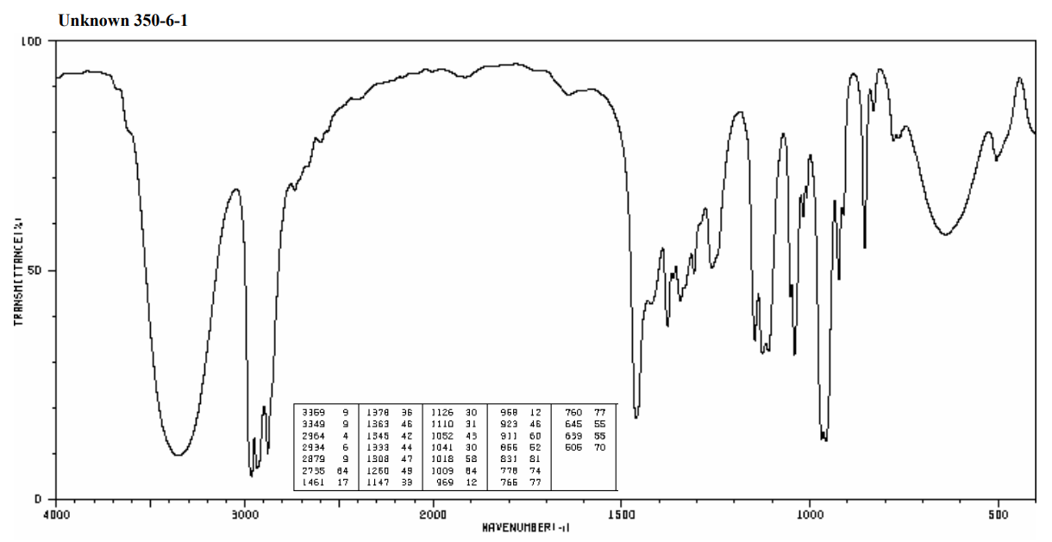

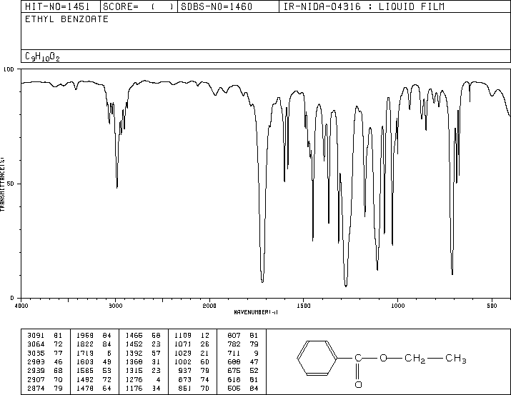

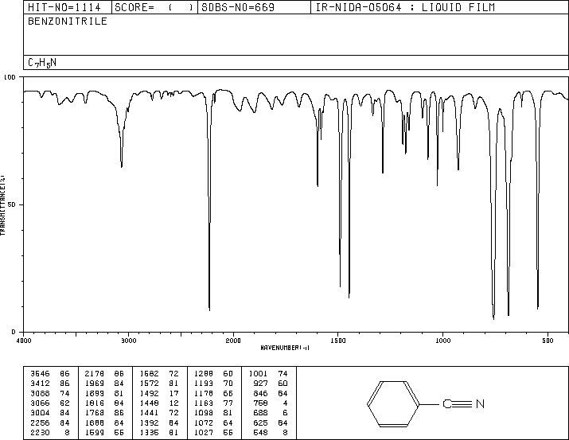
CHEM 350 Experiment 6 Report Form

Infrared Spectroscopy Tutorial

Date:___________

Student Name:___________________ ID Number:___________

Infrared Knowns

Fill in the following three (3) analyses tables to reflect your characterization of the spectra provided (above).

cyclohexanone | Absorption  Band# | Wavenumber (cm⁻¹) | Peak  Shape  (sharp, broad) | Peak Intensity  (strong, medium or weak) | Functional Group  Indicated
Functional Group(s) absent:

ethyl benzoate | Absorption  Band# | Wavenumber (cm⁻¹) | Peak  Shape  (sharp, broad) | Peak Intensity  (strong, medium or weak) | Functional Group  Indicated
Functional Group(s) absent:

benzonitrile | Absorption  Band# | Wavenumber (cm⁻¹) | Peak  Shape  (sharp, broad) | Peak Intensity  (strong, medium or ,weak) | Functional Group  Indicated
Functional Group(s) absent:

Infrared Unknowns

Select four (4) unknowns from the ‘Exp. 6 Infrared Unknown Downloads’ list:
Download 4 of the possible 20 spectra (PDFs). Please neatly fill out the table on the unknown spectra and remember to fully label each of the absorption bands identified and identify the compound. If you find the tables on the PDFs too small use this Word template to give yourself more space to write/type.
Code:  Name: | Absorption  Band# | Wavenumber (cm⁻¹) | Peak  Shape  (sharp, broad) | Peak Intensity  (strong, medium or weak) | Functional Group  Indicated
Functional Group absent:

Code:  Name: | Absorption  Band# | Wavenumber (cm⁻¹) | Peak  Shape  (sharp, broad) | Peak Intensity  (strong, medium or weak) | Functional Group  Indicated
Functional Group absent:

Code:  Name: | Absorption  Band# | Wavenumber (cm⁻¹) | Peak  Shape  (sharp, broad) | Peak Intensity  (strong, medium or weak) | Functional Group  Indicated
Functional Group absent:

Code:  Name: | Absorption  Band# | Wavenumber (cm⁻¹) | Peak  Shape  (sharp, broad) | Peak Intensity  (strong, medium or weak) | Functional Group  Indicated
Functional Group absent:
Questions

- What are the major differences you would see in the infrared spectra of an alkane, alkene, and alkyne?

- Consider the C=O absorption of three compounds: 2-butanone (1715 cm⁻¹), propanoyl chloride (1772 cm⁻¹), and propyl amide (1650 cm⁻¹). Explain the observed differences.

- Describe how IR spectroscopy might be used to monitor the progress of each of the following reactions.

`

I certify that this submitted laboratory report represents entirely my own efforts. I have read and understand the Athabasca University policies regarding, and sanctions for, plagiarism.

Signature: __________________________ Date: __________________________

Experiment 7:
Extraction of Usnic Acid from Lichen

Preparation

Review Section 5.3 on optical activity in the course wiki textbook.

Before you come to the laboratory you should have read the background information and completed the pre-lab questions.

Introduction

There are only 4 steps involved in performing a solid liquid extraction.

- Add the unknown mixture and extraction solvent to a vessel.
- Allow time for the extraction to take place.
- Gravity filter to remove the unwanted source material.
- Remove the solvent to concentrate the desired extracted solute.

Natural products are of very high interest to chemists. Well-known natural products include caffeine, trimyristin, and cinnamaldehyde.

Caffeine can be extracted from tea leaves (2-3% w/w) using boiling water, while trimyristin can be extracted from nutmeg (2-4% w/w) using dichloromethane, and cinnamaldehyde can be extracted from cinnamon using steam distillation. In this experiment, acetone is used to extract usnic acid from the lichen, ‘Old Mans Beard’.

After the usnic acid (C₁₈H₁₆O₇) is extracted and concentrated, the product is recrystallized, weighed and then a specific amount placed in the polarimeter and the specific optical rotation determined.

Figure 7.2. Structure of usnic acid (* = chiral or stereogenic C)

Chemicals, Equipment, Utilities Required

All glassware used for solid-liquid extraction must be clean and free of any organic contamination.

Chemicals | Equipment | Utilities
lichen (dried and crushed),  reagent & HPLC grade acetone,  ethanol,  L-tartaric acid,  distilled water, tetrahydrofuran,  ice. | -stirrer-hot Plate, lab jack, retort stands, utility clamps  -polarimeter  -melting-point apparatus  -hazardous waste disposal containers (in fume hood) | -115V electrical,  -water aspirator  -air-line

Procedure

Part A: Extraction of (+ / −) Usnic Acid
1. Place 10.0 g of previously oven dried (40º C) crushed or cut up lichen into a clean 500 mL Erlenmeyer flask containing a 1-inch magnetic stirrer and loosely capped with a cork stopper or Parafilm™. To the flask with lichen add 150 mL of acetone.

2. Mix the lichen and acetone at room temperature. For the first 30 minutes, periodically resubmerge any lichen that adheres to the sides of the flask. Allow the mixture to sit overnight.

Part B: Isolation of Usnic Acid
- Gravity filter the mixture, and collect the filtrate in a clean 250 mL Erlenmeyer flask.

2. Evaporate the acetone under a gentle stream of air in the hood with the flask suspended ~ 3 cm above a hot plate set on low or use a rotary evaporator (see Exp. 5) to remove almost all the acetone. Allow the last amount of acetone to evaporate at room temperature.

Part C: Purification and Characterization of Usnic Acid
- Recrystallize the crude usnic acid from as solution of acetone-95% ethanol (10:1). Dissolve the crystals in the minimum amount of hot acetone, and then add the ethanol.

- Collect the yellow crystals by vacuum filtration, wash with ice cold acetone and dry the crystals on a sheet of filter paper.

- Weigh the usnic acid to determine your yield, and calculate the percentage of the acid in the lichen by weight.

- Determine the melting point of the purified usnic acid, confirm the identity of usnic acid by mixed melting point procedure and compare it to the literature.

- Optional: The instructor may also obtain an IR spectrum of several samples of the purified material, and these will be compared to an authentic sample.

- While you wait for a suitable moment to determine the specific rotation of the usnic acid, familiarize yourself with the use of the polarimeter by determining the specific rotation of the unknown sample provided.

Part D: Polarimetry-The Specific Rotation of an Unknown Compound

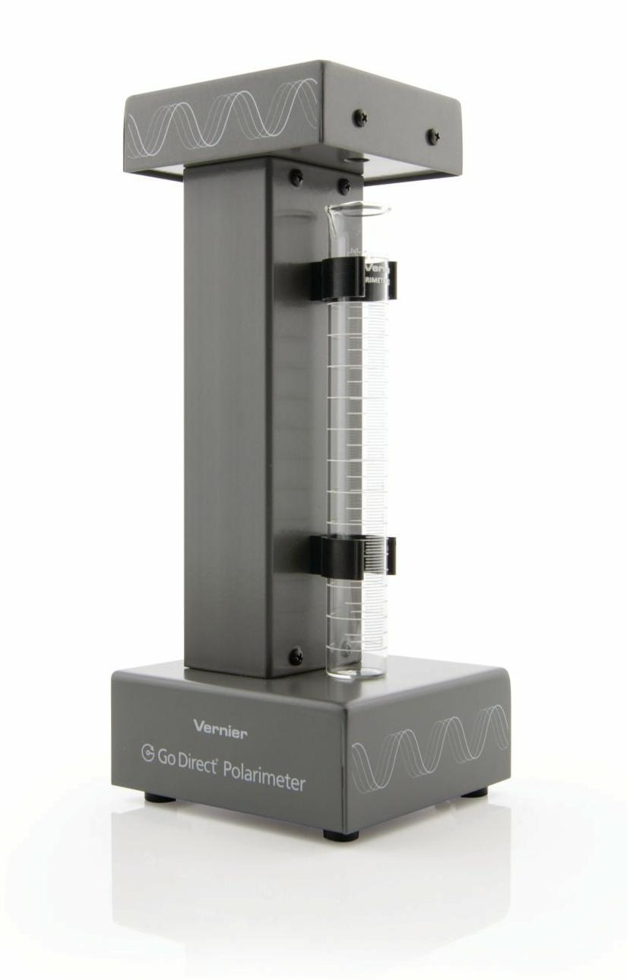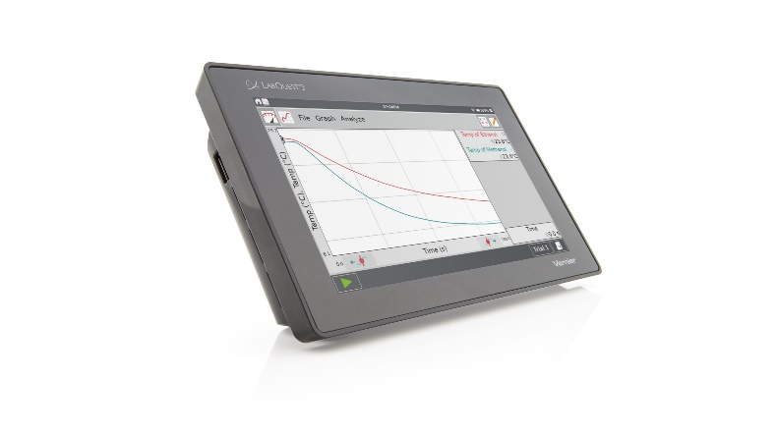
Figure 7.4. Go Direct Polarimeter and LabQuest3 Data-logger

- Prepare an aqueous solution of the given unknown by dissolving 5 to 6 g of solid (weighed-out on analytical balance) in a 25-mL volumetric flask.

- Connect the Go Direct Polarimeter to the LabQuest3 data-logger. The lab instructor will assist if necessary.

- Calibrate Go Direct Polarimeter.

- Pour distilled water or the appropriate solvent in the Go Direct Polarimeter cell to a height of 10 cm. It is important to read the height to the nearest 0.1 cm. Read to the bottom of the meniscus.
- Place the cell in Go Direct Polarimeter and select Finish Calibration.
- When the polarimeter is ready, select Done.

- You are now ready to add your optically active sample into the polarimeter cell.

- Rinse the polarimeter cell with a few millilitres of your optically active sample. Pour your sample into the polarimeter cell to a height of 10.0 cm (1.00 dm). It is important to read the height to the nearest 0.1 cm. Read to the bottom of the meniscus.
- Place the sample cell in the polarimeter.
- Start data collection. Data collection will stop automatically. Data are stored automatically in Instrumental Analysis. In LabQuest App, you can store a run by tapping the file cabinet icon on the graph screen.

- Record the first angle closest to 0° where the illumination is at a maximum. This is the observed angle of rotation for the optically active sample (α). There are several ways to locate this angle. However, to simply get the angle with the highest illumination, highlight the peak of interest in the LabQuest App. Cosine Squared: To incorporate all your data into the fit, you can fit the data to their true waveform, a cosine squared.

- In Instrumental Analysis, click or tap Graph Tools and select Curve Fit. Then select cosine squared from the dropdown list. In LabQuest App, choose Curve Fit from the Analyze menu. From the list of available General Equations, select Cosine Squared. The fit will run automatically. In this fit, the x-value corresponding to the maximum y-value is obtained from the negative of the phase shift parameter, –C. This is a nonlinear fit that undergoes numerous iterations and may not converge, which may result in an unreasonable answer. Make sure the resulting value is reasonable based on the data.

- Place the solution of the unknown in the container provided. Rinse the sample tube with water. Unless you are ready to determine the specific rotation of usnic acid, return the tube to the instructor.

Part E: Polarimetry—The Specific Rotation of Usnic Acid

1. After showing the instructor the usnic acid that you obtained from Part A, weigh-out, on an analytical balance, 80 mg of your sample into a clean 25 mL volumetric flask and add spectral grade tetrahydrofuran (THF) until at the 25.00 mL mark. If you do not have sufficient usnic acid, combine your product with that of another student or see your instructor.

2. Set up the polarimeter as described in Part D. This time, obtain the “blank” reading using an empty polarimeter tube instead of a tube filled with water. Rinse the tube with a small quantity of (+) or (−) usnic acid, then fill the tube with this substance and determine its observed rotation as described for the unknown compound in Part D. The specific rotation is then calculated using the equation given in the introduction to this experiment.

3. Place the usnic acid in the container provided. Clean the polarimeter tube with acetone and return the polarimeter tube to the instructor.

Safety

Usnic Acid is harmful if swallowed, inhaled or absorbed through the skin. Wear gloves. In case of contact, flush affected area with copious amounts of water. Inv-mus LD50 25 mg/kg.

Acetone (propanone) is an irritant to the eyes, skin and lungs, and harmful to the liver and kidneys if swallowed. Highly flammable. Use in a well-ventilated area. TLV (mg/m³) =1780.

95% Ethanol may contain denaturing substances that enhance its toxicity. Also flammable.

Tetrahydrofuran (THF) or diethylene oxide is harmful if inhaled. Exposure to vapors of THF in excess of 200 ppm in air will result in liver damage. TLV (mg/m³) =590.

Additional information about the potential hazards in handling these chemicals may be obtained from the Material Safety Data Sheets that are available in the laboratory.

Waste Disposal

Solutions containing the usnic acid (i.e., the filtrates from the suction filtrations) should be placed in the container provided.

Write-up and Calculations

Fill in the following form below and answer the post-lab questions. Use the Word version of the report form so you can add additional space for your answers. When complete save as a PDF and email as an attachment to your Academic Expert for grading.

CHEM 350 Experiment 7 Report Form

Extraction of Usnic Acid from Lichen

Date:___________

Student Name:___________________ ID Number:___________

Procedure:
(Ref: )
Changes/Modification:

Fill in the flowchart with procedural details, data, and key observations.
SAMPLE EXPERIMENT 7 FLOW CHART

REAGENT PROCEDURE / STEP OBSERVATION

Reagent
Equip.
Prep.

Reaction

Product
Recovery
(Rxn.
Workup)

Prod.
Charact.

Final appearance:

mp

mmp

etc.

Recrystallization

Evaporate Solvent by

Mix for :

Gravity Filter

Collected Filtrate

Discard
Lichen

___ mL
Acetone
___ g Lichen

Part A-C. Usnic Acid Extraction from Lichen

 | Mass  Lichen  (g) | Product Yield  (g) | Appearance of Crystals | Melting Point  (°C) | Mixed Melting Point.  (°C) | Reference Melting Point  (°C) | % Lichen (w/w)
( ) Usnic acid

Show % Weight of Lichen Calculation:

Part D-E. Results of Polarimetry Measurements for Unknown and Usnic Acid.

 | Mass  (g) | [Solution]  (g/mL) | Observed Rotation  (α)* | Corrected Observed Rotation  (α−blank) | Specific Rotation*  α_{D} | Reference Rotation  α_{D}²⁰ | Optical Purity
Unknown
(L-tartaric acid)
( ) Usnic acid

*At the temperature of solution during optical rotation determination:

Show specific rotation (α_{D}) and optical purity calculations for usnic acid:

for a liquid, and

for a solution.

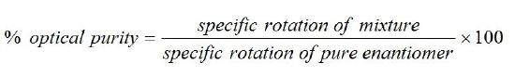

Questions

- What is a real-life example of solid-liquid extraction?

- Define the difference between diastereomers and enantiomers. Choose a specific example (e.g., glucose/fructose) to help explain your answer.

- Draw the Fischer and line/wedge diagrams for the two enantiomers of usnic acid. Label the drawings with the structure’s absolute configuration.

I certify that this submitted laboratory report represents entirely my own efforts. I have read and understand the Athabasca University policies regarding, and sanctions for, plagiarism.

Signature: __________________________ Date: __________________________

Experiment 8:
Preparation of Cyclohexene from Cyclohexanol

In this experiment you will use several techniques from previous experiments to carry out your first synthetic reaction in the lab (e.g., using a separatory funnel, drying of organic solvents, distillation, IR spectroscopy). In addition, you will learn how to pre-dry an organic solvent using sodium chloride (a.k.a. 'salting-out').

Preparation

Review Section 8.1 on preparing alkenes from alcohols and Section 11.7 on elimination reactions in the course wiki textbook.

Recall how to carry out a simple distillation (Experiment 3) and use a separatory funnel (Experiment 5).

Before you come to the laboratory you should have read the background information and completed the pre-lab questions.

Chemicals, Equipment, Utilities Required

All equipment used for the reaction must be clean and free of any organic contamination.

Chemicals | Equipment | Utilities
cyclohexanol (purified),  85% phosphoric acid,  vacuum (glass joint) grease,  sodium chloride,  10% sodium carbonate,  brine (sat. sodium chloride,  anhydrous calcium chloride,  ice,  distilled water,  wash acetone | -graduated cylinders  -heating mantle, lab jack, retort stands, utility clamps  -distillation apparatus (distillation flask, three way connector, thermometer adapter, condenser, vacuum adapter, receiving flask, boiling stones)  -125 mL separatory funnel  -hazardous waste disposal containers (in fume hood) | -115V electrical,  -cold water supply

Assembling Distillation Glassware and Using Heating Mantles

- Inspect all glassware for star-cracks (especially the distillation round bottom flask).

- Do not use a heating mantle with a damaged electrical cord.

The Use of Brine and Drying Agents

- Organic solvents that are wet (have been in previous contact with aqueous solutions) need to be dried before they are distilled. The is achieved by the addition of a solution of saturated sodium chloride (sat. NaCl(aq)). The brine helps to draw the bulk of the water from the organic solvent, while also limiting the amount of organic solvent that can dissolve in the brine (i.e., organic solvents are less soluble in brine than in water).

- Once the organic solvent has been pre-dried with brine, the final trace water can be bound by the addition of a suitable drying agent. The drying agent then can be removed by gravity filtration or decantation. Be careful. The over addition of a drying agent can significantly reduce your yield.

Procedure for Cyclohexene Synthesis
You must complete at least steps 1-8 before stopping.

- Reagent and Equipment Preparation

1. Use graduated cylinders to measure out 21 mL of cyclohexanol (previously distilled in Experiment 3) and 5 mL of 85% phosphoric acid (98.0 g/mol, d=1.7 g/mL, ~14.7 M) into a 100-mL round bottom flask.

Caution: 85% phosphoric acid is corrosive and viscous. Wear gloves, protect your eyes and work with it in the fume hood. Pipette carefully.

2. Add a few boiling stones, and then attach the flask to a simple distillation apparatus making sure that the thermometer has been positioned correctly (see Experiment 3). Note that the collecting vessel is a 50-mL round bottom flask, cooled in an ice-water bath.

- Reaction

3. Start the cooling water circulating through the condenser, and begin to heat the reaction mixture using a heating mantle.

4. As the cyclohexene begins to distil, the control on the heating mantle should be adjusted so that the temperature of this distilling vapour does not exceed 100º C. Record the temperature changes you observe and correct them for barometric pressure.

- Quenching the Reaction

5. When only a few millilitres of liquid remain in the distilling flask, stop the distillation by lowering the lab jack and removing the heating mantle. The appearance of white fumes in the distillation flask is a good indication that the distillation has proceeded far enough. Remember: Never try to distill to dryness! Proceed immediately to the next step.

- Reaction Workup/Product Recovery

6. Add solid sodium chloride to the distillate until no more salt will dissolve. The sodium chloride should be added little by little using a spatula, and the flask would be shaken after each addition.

7. Add enough 10% sodium carbonate solution to make the solution in the flask basic to litmus. A single Pasteur pipetteful is normally adequate. (Take care: Some gas may be evolved.) Transfer the neutralized mixture to a separatory funnel and separate the two layers. The aqueous layer should be drained through the stopcock and the upper layer poured through the neck of the separatory funnel into a 125-mL Erlenmeyer flask.

8. Wash the organic layer in the separatory funnel with 10 mL of brine (saturated sodium chloride). Remove and discard the wash/aqueous layer.

9. Add 2 to 3 g of anhydrous calcium chloride to the cyclohexene in the Erlenmeyer flask to remove residual water. Add a small scoop of calcium chloride and swirl the flask vigorously. If all of the pellets of calcium chloride are stuck to each other or to the walls of the flask, or if the liquid is cloudy, or if you can see visible aqueous solution, add more calcium chloride and swirl again. If some of the pellets are not sticking to anything and the liquid is clear (not cloudy), you have added enough. Place a cork stopper in the mouth of the flask and swirl the contents occasionally. The cyclohexene dries over a period of 10 to 15 minutes. It should be clear when all the water has been removed. While you are waiting, clean your condenser and prepare to carry out another simple distillation.

- Product Purification and Analysis

10. Gravity filter (or decant) the dry cyclohexene into a clean, dry 50-mL round bottom flask, and add a few boiling stones. Distill the cyclohexene, collecting the fraction that boils over a range of 80-85º C (corr.). Note: Remember that the boiling point of your product needs to be corrected for barometric pressure.

F. Product Analysis

11. Determine the yield (mass) of cyclohexene obtained, and calculate your percentage yield. Optional: Perform infrared spectroscopy on the sample. Determine the density of your sample by also measuring the volume of product (d=m/v), and determine the refractive index (n_{D}²⁰).

12. Transfer the sample to a suitably labelled screw cap vial and submit it to your instructor. Save this sample as it is needed for use in Experiment 6.

Safety

Cyclohexanol is flammable, irritating to the skin and eyes, and is harmful if inhaled or ingested.

Cyclohexene vapour irritates the eyes, skin and respiratory system. The liquid is harmful if swallowed. Highly flammable.

Phosphoric acid burns the skin and eyes, and causes serious internal injury if swallowed. Wear gloves and eye protection.

Sodium chloride and sodium carbonate do not normally constitute a safety hazard, but you should treat all chemicals with respect.

Saturated sodium chloride (brine) does not normally constitute a safety hazard, but you should treat all chemicals with respect.

Calcium chloride (anhydrous) is an irratant and is hygroscopic. Wash away any dust with lots of water.

Additional information about the potential hazards in handling these chemicals may be obtained from the Material Safety Data Sheets that are available in the laboratory.

Waste Disposal

Cyclohexanol/phosphoric acid residues should be placed in the container provided for this purpose.

The aqueous layer from the separation may be washed down the sink with plenty of water.

The cyclohexene residue from the final distillation should be placed in the bottle labelled “Organic Wastes: Non-halogenated.”

Write-up

Fill in the following form below and answer the post-lab questions. Use the Word version of the report form so you can add additional space for your answers. When complete save as a PDF and email as an attachment to your Academic Expert for grading.

CHEM 350 Experiment 8 Report Form

Preparation of Cyclohexene from Cyclohexanol

Date:___________

Student Name:___________________ ID Number:___________

Procedure:
(Ref: )
Changes/Modification:

Fill in the flowchart with procedural details, data, and key observations.
SAMPLE EXPERIMENT 8 FLOW CHART

REAGENT PROCEDURE / STEP OBSERVATION

Reagent
Equip.
Prep.

Reaction

Product
Recovery
(Rxn.
Workup)

Prod.
Charact.
Simple Distillation
Apparatus
Clean rb flask, condensor, vac. adapter, etc.
Add boiling stones.
_______ g cyclohexanol

_______ mL
conc. phosphoric acid

Distill

Discard
Residue

Predrying

___ g NaCl

___ mL
___ % Na₂CO₃
Neutralization

Dry Solvent

Gravity Filter or
Decant

___ g
anhydr. CaCl₂

Distillation

bp

density

atmospheric pressure

infrared spec.

Properties of the Acid-Catalyzed Dehydration Product, Cyclohexene

Calculations for theoretical yield, percent yield, and boiling point correction should be shown below the table. Note: ___________ was the limiting reagent, since the only other reagent involved in the reaction, phosphoric acid, served as a catalyst.

 | Mass  (g) | Appearance of Liquid | Boiling Pt.  (°C)  (/Pressure) | Theoretical Yield  (g) | % Yield
Cyclohexene

Boiling Point Pressure Correction:

Theoretical Yield Calculation:

% Yield Calculation:

Tabulation of Characteristic Infrared Absorptions for cyclohexanol and cyclohexene.

cyclohexanol | Peak# | Wavenumber (cm⁻¹) | Peak  Shape  (sharp, broad) | Peak Intensity  (strong, medium or ,weak) | Functional Group  Indicated

cyclohexene | Peak# | Wavenumber (cm⁻¹) | Peak  Shape  (sharp, broad) | Peak Intensity  (strong, medium or ,weak) | Functional Group  Indicated

Questions

- What is the purpose of adding 10% sodium carbonate solution to the distillate in step 7 of the procedure?

- Identify two possible by-products that could be formed from cyclohexanol in this experiment. (You may also want to search through your textbook to find what other reactions can occur between an alcohol and a concentrated mineral acid (e.g. phosphoric acid).

- What evidence do you have of the purity of your cyclohexene product? Explain.

- If you did a similar acid catalyzed dehydration of 4-methyl-2-pentanol you would have more than one product. Draw all the possible products of that reaction. [Hint: Remember intermediate hydride and alkyl shifts.]

I certify that this submitted laboratory report represents entirely my own efforts. I have read and understand the Athabasca University policies regarding, and sanctions for, plagiarism.

Signature: __________________________ Date: __________________________

Experiment 9:
The Nitration of Acetanilide

Preparation

Review Unit 16 on electrophilic aromatic substitution of benzene in the course wiki textbook.

Complete Experiments 1 through 5.

Before you come to the laboratory you should have read the background information and completed the pre-lab questions.

Prepare a flow chart for the procedure to be followed.

Introduction

In this experiment, you will use the sample of acetanilide purified in Experiment 2. The acetanilide (acetamido group is ortho-para directing) is dissolved in glacial acetic acid (which stabilizes the molecule and prevents it from degrading into aniline (a meta director), and then reacted with the strong electrophile, nitronium ion (NO₂⁺). The nitronium ion is formed when nitric acid and sulfuric acid react as follows (sulfuric acid is the stronger acid and therefore gives up its proton while nitric acid acts like a base and accepts a proton):

Figure 9.1: Formation of the nitrating reagent.

The overall reaction of acetanilide with nitric acid is shown below. Which is the limiting reagent?

Figure 9.2: Overall reaction of acetanilide forming p-nitroacetanilide.

To perform a desired synthesis, organic chemists often need to introduce a nitro group (-NO₂) into an aromatic ring. This goal is usually achieved by reacting the aromatic substrate with a nitrating mixture, often consisting of a mixture of concentrated nitric and sulfuric acids. The reactive species in the nitrating mixture is the nitronium ion, (NO₂⁺), which is a strong electrophile and readily attacks aromatic systems (see Figure 9.3).

Figure 9.3: Mechanism of the nitration of benzene

The introduction of a nitro group into an aromatic ring is often an important step in an organic synthesis. Once introduced, the nitro group can be easily reduced to an amino group, and the amine can subsequently be converted to a variety of compounds via the formation of a diazonium salt (see “Aliphatic Amines” in McMurry’s Organic Chemistry). However, the rather drastic conditions needed to bring about an electrophilic aromatic substitution can place limitations on this general approach.

For example, aniline is so susceptible to oxidation that the nitric acid present in the nitrating mixture would oxidize most of the aniline before nitration could take place. Also, the anilinium ion that would be formed in the strongly acidic medium (see Figure 9.4) contains the deactivating, meta-directing -NH₃⁺ substituent. Thus, even if

Figure 9.4: Formation of the anilinium ion from aniline

the oxidation of aniline could be prevented, the direct nitration of this compound would yield m-nitroaniline rather than the ortho- and para-substituted products. How, then, could a chemist prepare p-nitroaniline? One solution is to "protect'' the sensitive amino group by acetylation, to nitrate the acetanilide so formed, and to hydrolyze the p-nitroacetanilide to p-nitroaniline. This sequence of reactions is shown in Figure 9.5.

Figure 9.5: The preparation of p-nitroaniline

In this experiment you will perform only the middle portion of this sequence; that is, the nitration and purification of acetanilide (see Fig. 9.6).

Figure 9.6: Preferred direction of nitration of acetanilide.

Note: the type of substituents in aromatic compounds have an effect on electrophilic substitution. The acetamido (CH₃CONH-) group is a moderately activating group (so is the methoxy group (CH₃O-) while the amino (-NH₂) and hydroxyl (-OH) are strong activating groups. The nitro group (-NO₂) is a strong deactivator). Activating groups are ortho-para directors and deactivating groups are meta directors.

Infrared Spectroscopy

Do not worry too much about the details of operating the spectrometer. Your instructor will provide you with specific instructions for the instrument that is available at your lab site.

Chemicals, Equipment, Utilities Required

All glassware used must be clean of any organic contamination (especially acetone).

Chemicals | Equipment | Utilities
acetanilide (purified)  acetic acid (glacial)  nitric acid (conc.)  sulfuric acid (conc.)  ice  distilled water  ethanol  wash acetone | -stirrer/hotplate, lab jack, retort stands, utility clamps, latex gloves  -Büchner funnel & adapter, filter flask, Whatman #1 filter paper circle, sample vial + label  -recrystallization (flat bottom) dish  -melting-point apparatus  -hazardous waste disposal containers (in fume hood) | -115V electrical,  -water aspirator

Concentrated Acids

Concentrated acid and water react in a vigorous exothermic reaction, releasing heat, sometimes boiling the liquid. When you add water to acid, the water boils and the acid may splatter and splash!

- Dilute all conc. acids to < 3M using cold water before rinsing down the drain.
- Always add acid to water (AtoW).

Treat all glassware that has contacted concentrated acids with extreme care. Small amounts of the acid are coating the surface and must be diluted and rinsed away. To rinse away the acid
- in a sink, turn on the water, cold and slow flow.
- pointing the opening of the vessel away from you, place the acid contaminated glassware beneath the stream of water until near overflowing. Dump the contents down the drain and flush the glassware 2 more times with the water.
- finally, clean the glassware with hot soapy water, rinse with hot water, and >3 times with distilled water. Dry with acetone and air-dry or oven dry to allow the acetone to evaporate before using the glassware for measuring more reagents. This is particularly important in this experiment, as any trace acetone will react with the nitronium ion, producing a coloured impurity.

Procedure

1. Carefully add 3 mL of concentrated nitric acid (15 mol L⁻¹) to 4 mL of concentrated sulfuric acid (18 mol L⁻¹) in a very clean 50 mL flask. Cool the resulting nitrating mixture in an ice bath. Have the flask clamped into position in the ice bath to keep the flask from tipping over!

Caution: Nitric acid, sulfuric acid and the nitrating mixture are highly corrosive. Wear gloves, protect your eyes, and work in a fume hood. Excess nitric and sulfuric acid measured out should be properly disposed. See your instructor.

- Place 10 mL of concentrated (i.e., 18 mol L⁻¹) sulfuric acid contained in a 125-mL Erlenmeyer flask and cool in an ice-water bath.

Caution: Sulfuric acid is extremely hazardous. Wear gloves and proper eye protection.

- Meanwhile, take the acetanilide you purified in Experiment 2 and dissolve approximately 7.0 g of it in 7 mL of glacial (100%) acetic acid in a 50 mL flask. Warm the mixture on a hot plate set to 2 in a fume hood.

Caution: Acetic acid is corrosive and its vapour is extremely irritating. Wear gloves, protect your eyes, and work in a fume hood.

- Once the solution is dissolved, use a Pasteur pipette to slowly add it, while stirring, to the 10 mL of concentrated (18 mol·L−1) sulfuric acid in a 125-mL Erlenmeyer flask, which is kept cool in an ice-water bath (as described in step 2 above).

Continue to cool the solution to about 10º C (this can take ~30 min). Use lots of ice, and swirl frequently.

- Use a Pasteur pipette to slowly transfer the nitrating mixture prepared in step 1 to the Erlenmeyer flask containing the acetanilide solution prepared in step 3. Swirl the flask vigorously and continuously during the addition and keep the temperature of the mixture below 20° C by cooling in an ice-water bath. If the temperature approaches 20° C, stop adding the nitrating mixture until the temperature cools again. The acetanilide solution will be very viscous and difficult to mix, but it is essential that it be well mixed during the reaction. Failure to mix can result in a layer of nitrating mixture forming on top of the acetanilide solution, and rapid reaction with uncontrolled temperature increase leading to unwanted reactions and poor yield when mixing finally occurs.

- When all the nitrating mixture has been added, allow the reaction mixture to stand at room temperature for 30 minutes.

- Add the reaction mixture slowly, with stirring, to a mixture of 100 mL of water and 25 g of ice in a 400-mL beaker. (You should have a frothy, pale-yellow slurry.)

- Collect the solid by suction filtration (refer to Experiment 2, if necessary). Break up the solid with a spatula, being careful not to tear the filter paper, and wash the solid with cold water.

- Turn off the vacuum, add 100 mL of cold distilled water to the funnel, and allow the solid to become thoroughly wet. After a couple of minutes, turn the vacuum back on to draw off the water.

- Repeat step 9. If available, use universal indicator paper to Use blue litmus paper to test the wash water collected in the filter flask to see if it is still strongly acidic. If it is below pH 2, you should repeat step 9 again. If universal indicator paper is not available, repeat step 9 a total of five times.

- When the wash water is no longer strongly acidic, dry the solid under vacuum for at least 60 minutes (or allow to air dry overnight).

- Determine the mass of crude p-nitroacetanilide obtained. Recrystallize the product using a 4:1 mixture of ethanol and water. You should expect to use about 100-150 mL of solvent. Remember that using either too much or too little solvent will reduce your final yield.

- When your product is dry (you may have to leave it drying in air until your next laboratory session), determine its yield and melting point.

- Ask your instructor to assist you in obtaining an infrared spectrum of both your starting material (acetanilide) and your product (4-nitroacetanilide).

Safety

Acetanilide was formerly used as a dusting powder, as a mild antiseptic and anaesthetic. It can be harmful if taken internally.

p-Nitroacetanilide is not considered to be particularly hazardous; however, you should avoid allowing this compound to come into contact with your skin or eyes. Wash your hands before eating.

Concentrated nitric acid is a corrosive liquid with an irritating vapour. Protect your hands and eyes. Use only in a fume hood.

Concentrated sulfuric acid is very corrosive to eyes, skin and other materials. Wear gloves and protect your eyes.

Glacial acetic acid can cause burns. Its vapour is irritating to the skin and eyes. Wear gloves and use only in a fume hood. Poisonous if swallowed.

Ethanol can be poisonous if swallowed. The denaturing substances present in laboratory ethanol increase its toxicity. Highly flammable.

Waste Disposal

Excess concentrated nitric and sulfuric acid measured out during Step 1 of the procedure must be neutralized before discarding. See your instructor for the procedure.

The acidic filtrate and washings from the suction filtrations should be diluted with copious amounts of water and washed down the drain.

The ethanol/water mixture from the recrystallization should be placed in the container provided.

Write-up

A formal report is required for Experiment 9. Use the formal report template (Word) and follow the instruction outlined in “Writing Laboratory Reports.” When complete save as a PDF and email as an attachment to your Academic Expert for grading.

Questions

Answers to be submitted with your lab report.

- During the nitration of acetanilide care is taken to keep the reaction mixture cool. What do you think might be the consequences of allowing the reaction mixture to become too warm?

- What organic compound (other than ethanol) would you reasonably expect to isolate from the ethanol/water mixture that was used to recrystallize your 4-nitroacetanilide?

- Is there a way you could suggest to improve the experiment (should you do it again)?

Lab Data Sheet

Fill out this one-page form as you work in the lab and have your instructor sign it off. It will ensure that you have the bare minimum data from the experiments before going home. Of course, you should also keep a lab notebook to record more detailed observations and measurements. Also, make sure to share any work being done together with a partner(s) before leaving the lab sessions.

Athabasca University
CHEM 350: ORGANIC CHEMISTRY I
PREPARATION, PERFORMANCE, AND PRODUCT EVALUATION FORM

NAME: AU ID: DATE:

 | PRODUCT | RESULTS | YEILD or | UNKNOWN |  |  | PRODUCT CHARACTERISTICS
EXP. # | SUBMITTED | FOR: | Amt. Used | ID | DESCRIPTION | M.P./B.P. | IR(Y/N) | RI Temp | RI/SpecRot | BaroPress | Other
1 | unknown code: | Single M.P. | N/A |  |  |  | N/A | N/A | N/A | N/A
 | unknown code: | Mixed M.P | N/A |  |  |  | N/A | N/A | N/A | N/A
2 | ACETANILIDE | Yield (g) |  | N/A |  |  | N/A | N/A | N/A | N/A
 | Imputre Acetanalide | Amt. (g) |  | N/A |  |  | N/A | N/A | N/A | N/A
3 | A. CYCLOHEXANOL | Simple Dist. |  | N/A |  |  | N/A | N/A | N/A
 | B. FACTL DISTILLAT'N | 80-85 C |  | N/A |  |  | N/A | N/A | N/A
 | Amt. Part A= | 85-100 C |  | N/A |  |  | N/A | N/A | N/A
 | Amt. Part B= | 100-105 C |  | N/A |  |  | N/A | N/A | N/A
4 | CYCLOHEXANOL | Ref. Index | N/A | N/A | N/A |  | N/A |  |  | N/A
 | FRACR'L DISTIL. | 80-85 C | N/A | N/A | N/A |  | N/A |  |  | N/A
 |  | 85-100 C | N/A | N/A | N/A |  | N/A |  |  | N/A
 |  | 100-105 C | N/A | N/A | N/A |  | N/A |  |  | N/A
5 | unknown code: | Amt. Used. (g) |  |  |  | N/A | N/A | N/A | N/A | N/A
 | ORGANIC ACID | Yield/M.P. |  |  |  |  | N/A | N/A | N/A | N/A
 | ORGANIC BASE | Yield/M.P. |  |  |  |  | N/A | N/A | N/A | N/A
 | NEUTRAL | Yield/M.P. |  |  |  |  | N/A | N/A | N/A | N/A
6 | INFRARED SPECTRA | CH-tests | N/A | N/A | N/A | N/A | N/A | N/A | N/A | N/A
 | UNKNOWN# (4) |  | N/A | Pick 4 | N/A | N/A |  | N/A | N/A | N/A
7 | USNIC ACID | Sp. Rot. |  | N/A |  |  | N/A | N/A |  | N/A
 | Amt. Lichen= |  | N/A | N/A |  | N/A | N/A | N/A | N/A | N/A
 |  | Unk'n Sp Rot. | N/A |  |  | N/A | N/A | N/A |  | N/A
8 | CYCLOHEXENE | Yield/B.P./RI |  | N/A
 | cyclohexanol | Amt. (mL) |  | N/A |  |  |  | N/A | N/A
9 | 4-NITROACETANILIDE | Yield (g) |  | N/A |  |  | N/A | N/A | N/A | N/A
 | acetanilide | Amt. (g) |  | N/A |  |  |  | N/A | N/A | N/A

N/A: not applicable
Instructor Initals:
Instructor Grade /100

If there are no 100-mL heating mantles available, use a 250-mL mantle and flask, and 75 mL of cyclohexanol.
As in Part A, if a 100-mL heating mantle is not available, use a 250-mL flask and mantle. If this is necessary, the volume of cyclohexane-toluene mixture used should be increased to 75 mL.
Include a copy of your IR spectrum.

